Report of the Survey among the Claretian Family
for preparing Laudato Si Roll-Out
Plan for the upcoming 7 years.

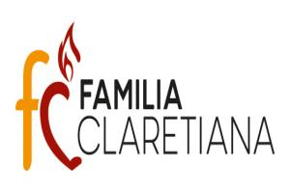
Table of contents
Introduction 4
Initiatives of Vatican 4
Claretian Family towards Integral Ecology 5
How to work on this report 5
The population of the survey 6
Laudato Si Goal - 1: Cry of the Earth 9
1 A) The Bible and Laudato Si on the Cry of the Earth: 9
1 B) Commitments: 9
1 C) Interpretation of the data: 11
Laudato Si Goal – 2. Cry of the Poor 12
2 A) The Bible and Laudato Si on the Cry of the Poor: 12
2 B) Commitments: 12
2 C) Interpretation of the data: 14
Laudato Si GOAL – 3. Ecological Economics: 15
3 A) The Bible and Laudato Si on the Ecological Economics: 15
3 B) Commitments: 15
3 C) Interpretation of the data: 17
Laudato Si Goal– 4. Sustainable Lifestyle: 18
4 A) The Bible and Laudato Si on leading Sustainable Lifestyle: 18
4 B) Commitments: 18
4 C) Interpretation of the data: 20
Laudato Si Goal– 5. Ecological Education: 21
5 A) The Bible and Laudato Si on Ecological Education: 21
5 B) Commitments: 22
5 C) Interpretation of the data: 24
Laudato Si Goal– 6. Ecological Spirituality: 25
6 A) The Bible and Laudato Si on Ecological Spirituality: 25
6 B) Commitments: 25
6 C) Interpretation of the data: 27
Laudato Si Goal– 7. Community involvement in Advocacy and Campaign 28
7 A) The Bible and Laudato Si on doing mission with others in network: 28
7 B) Commitments: 28
7 C) Interpretation of the data: 30
Conclusion: 30

Madrid, 13 May 2021

Dear members of the Claretian Family,
From the General Secretariat JPIC-CMF, we are reminded of Pope Francis' call for all Catholics - Families, Parishes, Dioceses, Schools, Universities, Companies, Farms, Hospitals, Religious Congregations, Institutes of Consecrated Life, Societies of Apostolic Life... - to live the values of the Encyclical Laudato Si (LS) on the care of the common home.
With this concern and commitment, the General Team of SoMi of the Claretian Missionaries (CMF) together with the representatives of the Branches of the Claretian Family, has conducted a survey on the seven values of LS. The result of the survey indicates that there are already certain programmes that we are following; and it also suggests in this report the new programmes that can be added.
Therefore, we request all the Branches of the Claretian Family to prepare a "Laudato Si Action Plan", appropriate to their respective context, inspired by the result of the above-mentioned survey. In this way we will be able to live the passion of St. Anthony Mary Claret who worked, full of creativity and tenderness, for the empowerment of the poor, excluded and discarded by society, with a deep ecclesial sense, and we will join the efforts of all peoples for the care of the common home. Thank you very much.
A strong fraternal embrace in communion of prayer and mission,

Fanny Fernandes
HICM – Coordinadora EC

Introduction

Greetings of Peace, Joy and Universal Goodwill to you in the person of Jesus. The destruction of biodiversity by human creates the conditions for new viruses and diseases like COVID-19 (Vidal, John. "Destroyed habitat creates the perfect conditions for coronavirus to emerge." Scientific American 18,2020). To save the environment the Paris Climate agreement (November 2016) has proposed to limit the global temperature rise between 1.5 to 2 degrees Celsius above the pre-industrial level. To achieve this the allowed carbon budget till the year 2100 is 2860 Giga Tones (Gt). But presently the annual global CO2 emission is 40 Gt. At this rate, the global CO2 emission in 2100 will be 3320 Gt, going beyond the budget.

Pope Francis has observed that the earth herself is burdened and laid waste (LS 2). This ecological destruction summons for an urgent and profound interior conversion (LS217). As John the Baptist has said, The axe is already at the root of the trees, and every tree that does not produce good fruit will be cut down and thrown into the fire (Mt 3,10). We see the bodies of the innocent victims of corona-19 being left in fire, in rivers and in street. But humans have the capacity to adopt eco-friendly modes of life. Hence, Pope Francis has made an urgent call to respond to the Ecological Crisis on March 3, 2020, in the context of the Laudato Si (LS) week during the 5th Anniversary of LS. The video message can be accessed in:
http://www.humandevelopment.va/en/news/the-holy-fater-s-video-message-for-the-laudato-si-week.html.

Initiatives of Vatican

To respond to that call, the Care for Creation section of the Dicastery for Promoting Integral Human Development (DPIHD), along with Global Catholic Climate Movement (GCCM) has organized Laudato Si’ Roll-Out Plan for 2020 and Beyond.

The DPIHD has identified 7 Laudato Si Goals (LSG): Cry of the Earth, Cry of the Poor, Ecological Economics, Sustainable Lifestyle, Ecological Education, Ecological Spirituality and Advocacy and campaign. Catholic Families, Parishes, Dioceses, Schools, Universities, Businesses/Farms/Hospitals, Religious Congregations and other Institutes of Consecrated Life are invited live these values in their daily life and mission for 7 years. The assumption is that any action that is lived for 7 years can become habitual. To Initiate Transformation at the level of the Church / Society there has to be a critical mass of 3.5% practitioners but to Effect Systemic Change 21 to 25% are needed. The Catholic Church aims to reach the critical mass within the Church as early as possible and also wishes to contribute to reach critical mass in the civil society, in network with other organisations.

The official launching of the Roll-out plan by Vatican was on May 25, 2021 at the conclusion of the LS 5th anniversary. The message of Pope can be accessed: https://www.vaticannews.va/en/pope/news/2021-05/pope-francis-videomessage-laudato-si-platform.html. In 2021 a certain number of families and institutions can start living the ecological programs with the aim of following them for 7 years. Every year more families and institutions are encouraged to begin their 7-year journey. Like this it will go on, for each of the coming years of this decade (2020-2030). In this way it is hoped to arrive at the ‘critical mass’ needed for radical ecological transformation.

Claretian Family towards Integral Ecology

The Claretian Family (CF) also joins and is willing to respond to this ecclesial invitation. The environmental care is not entirely new to us. We have been following ecological programs in our lives and mission, and many of our members know and promote the sustainable use of the natural resources. But these have not been quantified and counted to the population of practitioners. We want to encourage further more members of the CF to follow LSGs. Thus, we want to join the wave towards the ecological conversion that is flowing in our Church and in our society. For this, a conscious planning and practice is required.

How to work on this report

- The objectives of the survey are:
- to collect the past ecological practices; to inspire the members to adopt further new actions.
- to present to the branches of CF, a collection of action programs for LSGs, which can in turn serve as samples for preparing Laudato Si Roll-Out plan appropriate to them.

- The data for each goal is composed of:
- A brief explanation of the meaning of the goal.
- Three inspirational quotes from the Bible and Laudato Si pertaining to the Goal.
- The ecological activities participated in the last three years.
- The activities opted by the respondents among the given choices for future living.
- Additional proposals by the respondents apart from the given choices.
- Brief interpretation of the data, coming from the concrete experience of the respondents.

- Towards making the locally suitable plan, the data on the present practice, the options made among the given choices for future living, the additional suggestions and the interpretation of the data can serve as reference to choose the actions for the plan.

- The leadership team of each Claretian Family branch is invited to motivate their members to adopt the proposals to their contexts. All branches of the CF at the local levels are expected to invite their members, communities, families and apostolates to inculcate at least some of the appropriate proposals into their personal, community and pastoral plans.

- The members, communities, families, apostolates (parishes, schools, social institutions, etc.), Major organisms/Regions can make a pledge in the following link of Laudato Si Action Platform: https://laudatosiactionplatform.org/pledge-your-commitment/ and begin their journey in view of doing it for at least 7 years.

- Annual evaluation needs to be held and the report of which should be sent to the Claretian Team at the United Nations (cmf.ngo.un@gmail.com), in view of sharing our local experiences with the international community. Guidelines will be provided for evaluation and reporting.

The population of the survey

Survey sample
The total population of the CF at the beginning of this survey was around 5046 members. Survey is done among the 9.5% population (456 CF respondents and 22 CF collaborators = 478), employing Microsoft Forms adopting non-probability purposive sampling method.

Interpretation of the data
The respondents are from 55 countries; 85% of them are in the vibrant age between 30 and 60 years; the gender distribution of 35% female and 65% male are in proportion to the gender composition of CF; the numerical distribution among the branches of CF is in proportion to the respective population. So, it can be concluded that the results of the survey correspond to the country, age, gender, and population distribution of CF.

Graphics
In the next two pages, we include a graphical representation of the survey sample based on the Country where they are living, age, gender and Claretian Family Branch.

The Country Distribution of Respondents
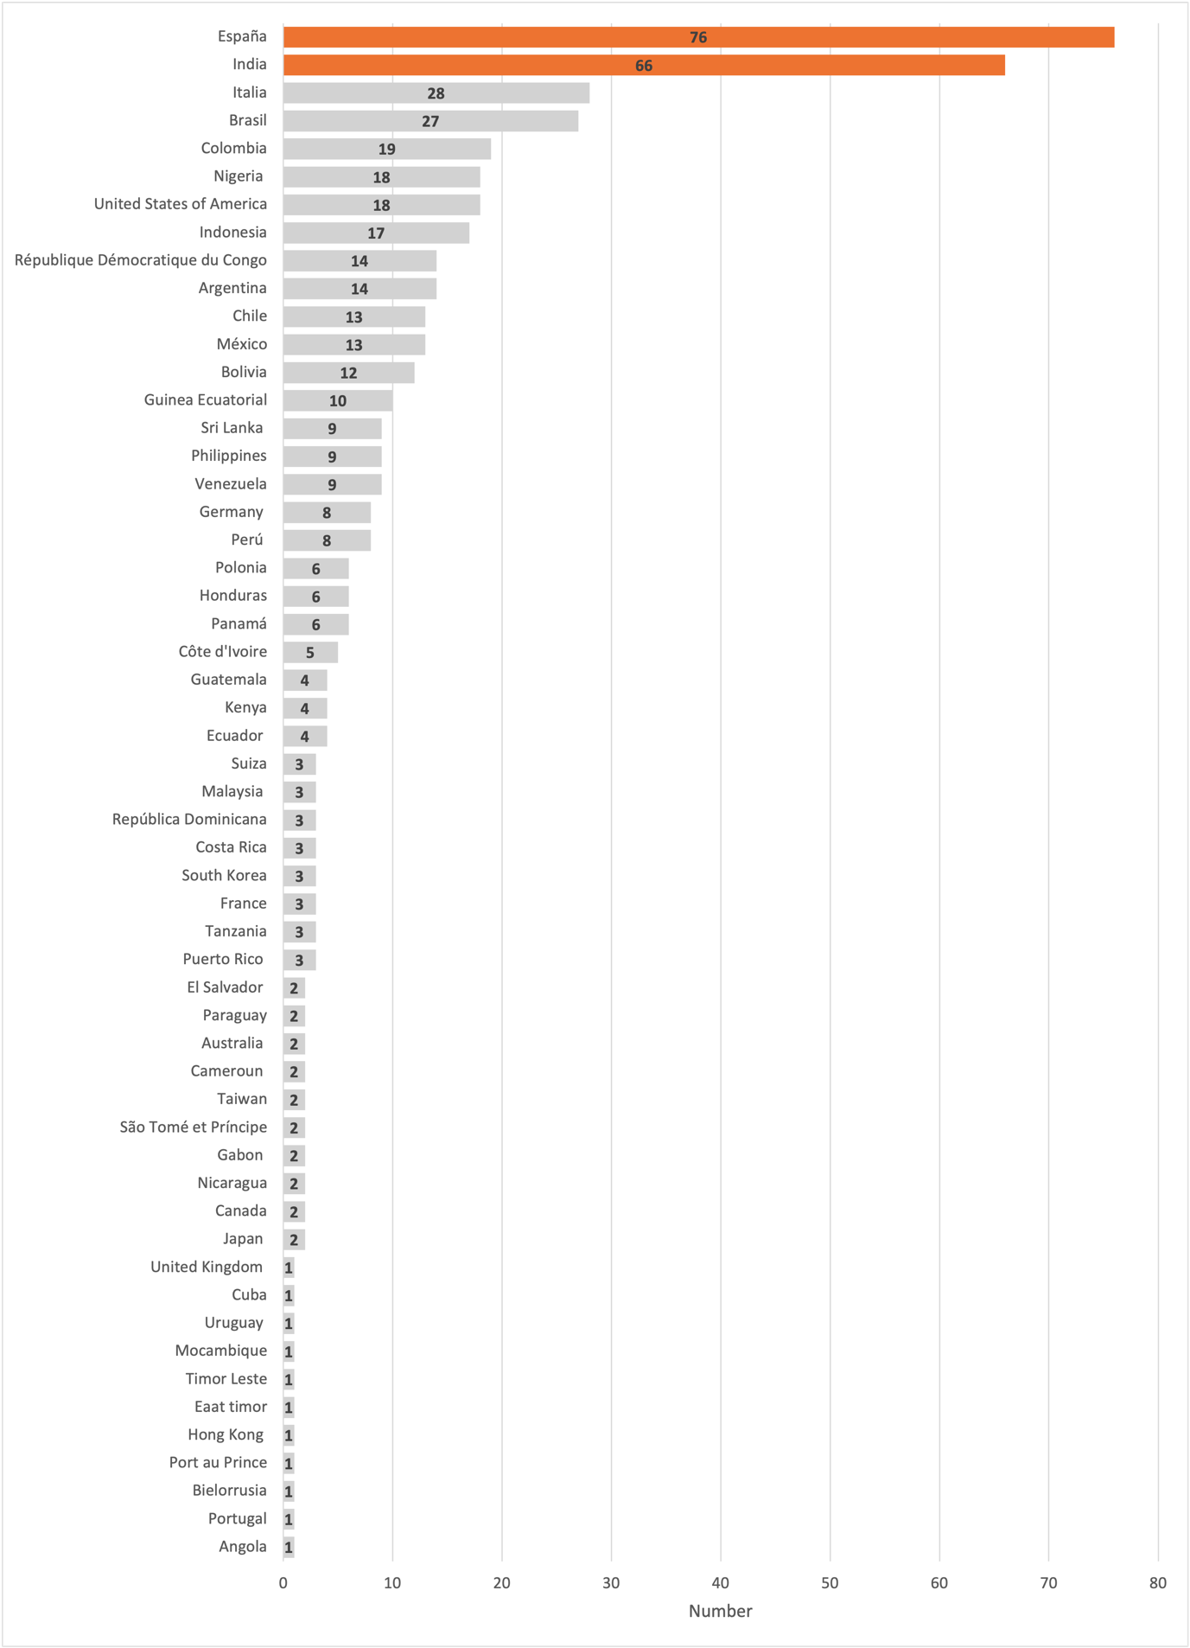
Age Distribution
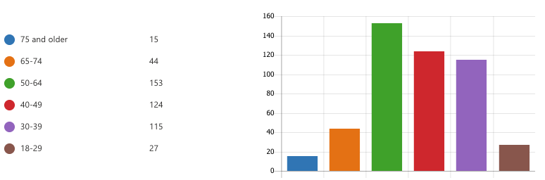

Gender Distribution

Claretian Family Distribution
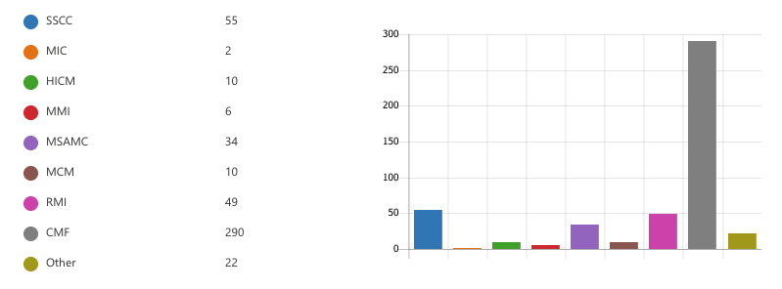

Laudato Si Goal - 1: Cry of the Earth

It refers to the challenges faced by the earth, such as climate change, pollution, acidification of the oceans, massive destruction of forests and wetlands, and other natural habitat.

1 A) The Bible and Laudato Si on the Cry of the Earth:

We know that the whole creation has been groaning as in the pains of childbirth right up to the present time (Romans 8,22)

The earth mourns and withers; the world languishes and withers; the highest people of the earth languish. The earth lies defiled under its inhabitants; for they have transgressed the laws, violated the statutes, broken the everlasting covenant (Isiah 24: 4-5)

I brought you into a plentiful land to enjoy its fruits and its good things. But when you came in, you defiled my land and made my heritage an abomination (Jeramiah 2,7)
The earth, our home, is beginning to look more and more like an immense pile of filth. In many parts of the planet, the elderly lament that once beautiful landscapes are now covered with rubbish (LS 21)
There is an urgent need to develop policies so that, in the next few years, the emission of carbon dioxide and other highly polluting gases can be drastically reduced, for example, substituting for fossil fuels and developing sources of renewable energy (LS 26)
Never have we so hurt and mistreated our common home as we have, in the last two hundred years (LS 53)

1 B) Commitments:

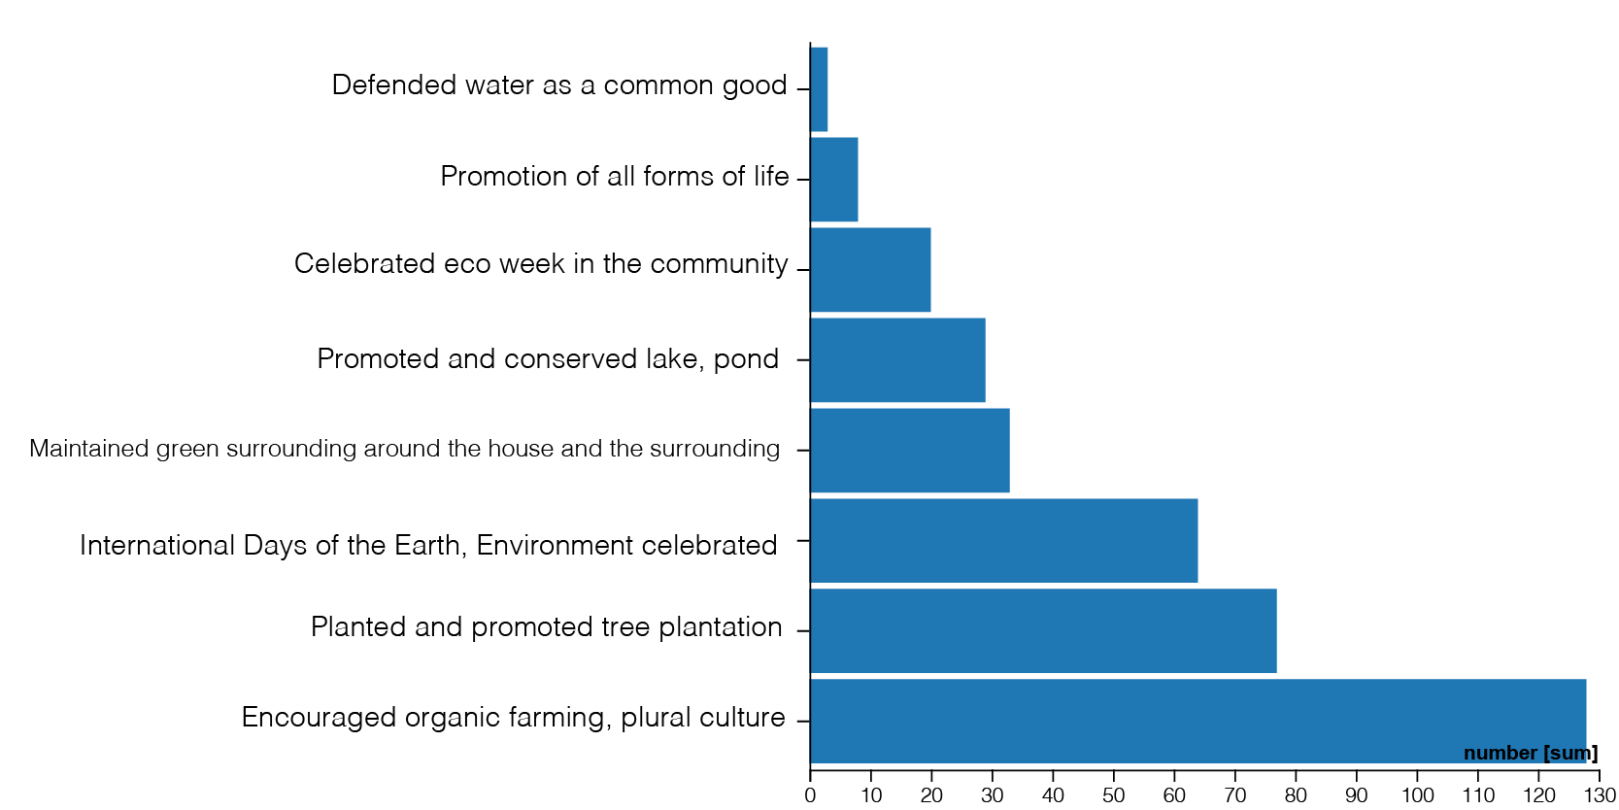
The activities we participated, during the last 3 years, to respond to the cry of the Earth:

The new commitments that we want to make at least for the next 7 years:
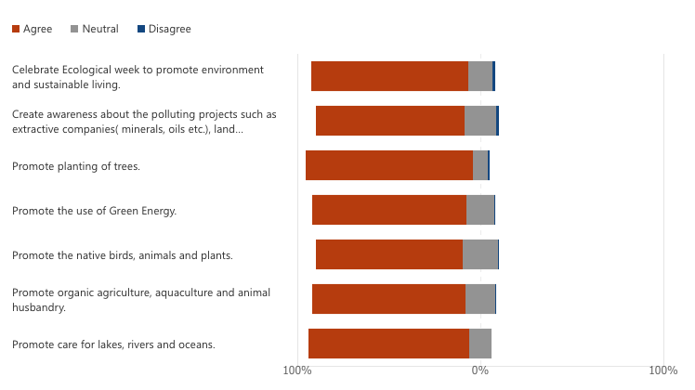

The additional commitments apart from the above:

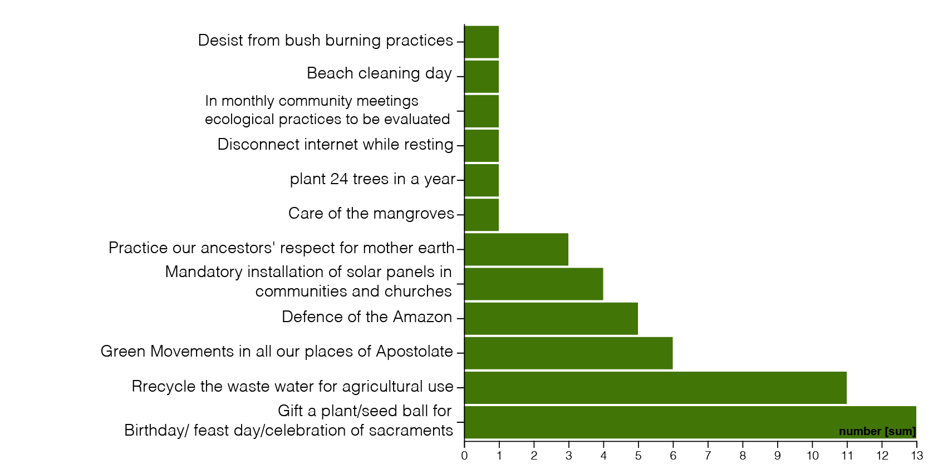

1 C) Interpretation of the data:

There has been ecological concern and practice among us. The celebration of eco week is praise worthy. Now there is greater awareness about the environmental and bodily health which is indicated by the options for organic farming, plural agriculture and green surrounding. The issues related to ocean, commercialisation of water and environmental pollution are not strongly opted. There are encouraging proposals such as gifting plant or seed ball, each one planting 24 saplings annually, disconnecting internet while resting, beach cleaning, mandatory installations of solar panel in the community and Church buildings.

Laudato Si Goal – 2. Cry of the Poor

It means that the impacts of the deterioration of the environment are suffered primarily by the most vulnerable people (the poor, the indigenous, the children, the women).

2 A) The Bible and Laudato Si on the Cry of the Poor:

When you reap the harvest of your land, do not reap to the very edges of your field or gather the gleanings of your harvest. Do not go over your vineyard a second time or pick up the grapes that have fallen. Leave them for the poor and the foreigner. I am the Lord your God (Leviticus 19, 9-10)

They caused the cry of the poor to come before him, so that he heard the cry of the needy (Job 34,28)
When you give a banquet, invite the poor, the crippled, the lame, the blind and you will be blessed (Lk 13,14)
Both everyday experience and scientific research show that the gravest effects of all attacks on the environment are suffered by the poorest (LS 48)

Generally speaking, there is little clear awareness of problems which especially affect the excluded people. Yet they are the majority of the planet’s population, billions of people (LS 49)

A true “ecological debt” exists, particularly between the global north and south, connected to commercial imbalances with effects on the environment, and the disproportionate use of natural resources by certain countries over long periods of time (LS 51)

2 B) Commitments:

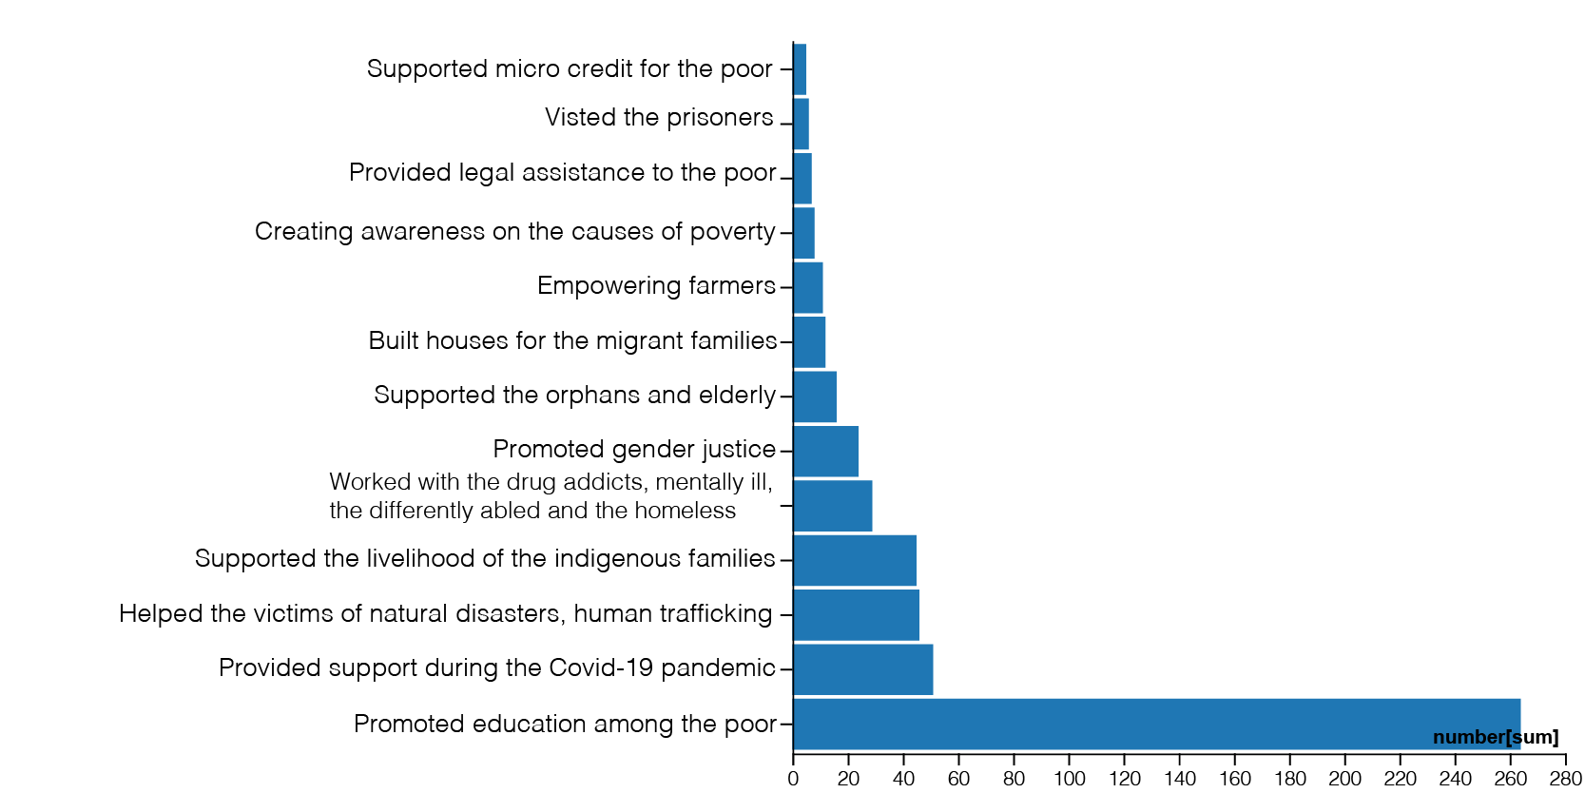
The activities we participated, during the last 3 years, to respond to the Cry of the Poor:

The new commitments that we you want to make at least for the next 7 years:
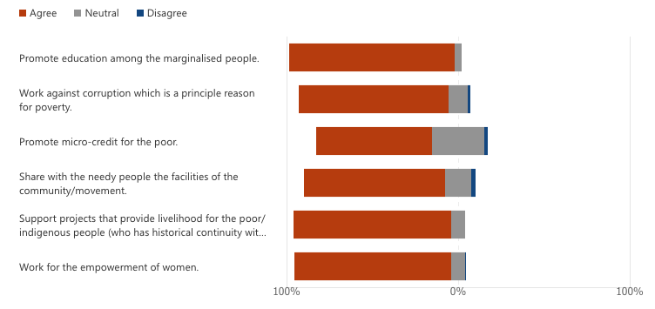

The additional commitments apart from the above:
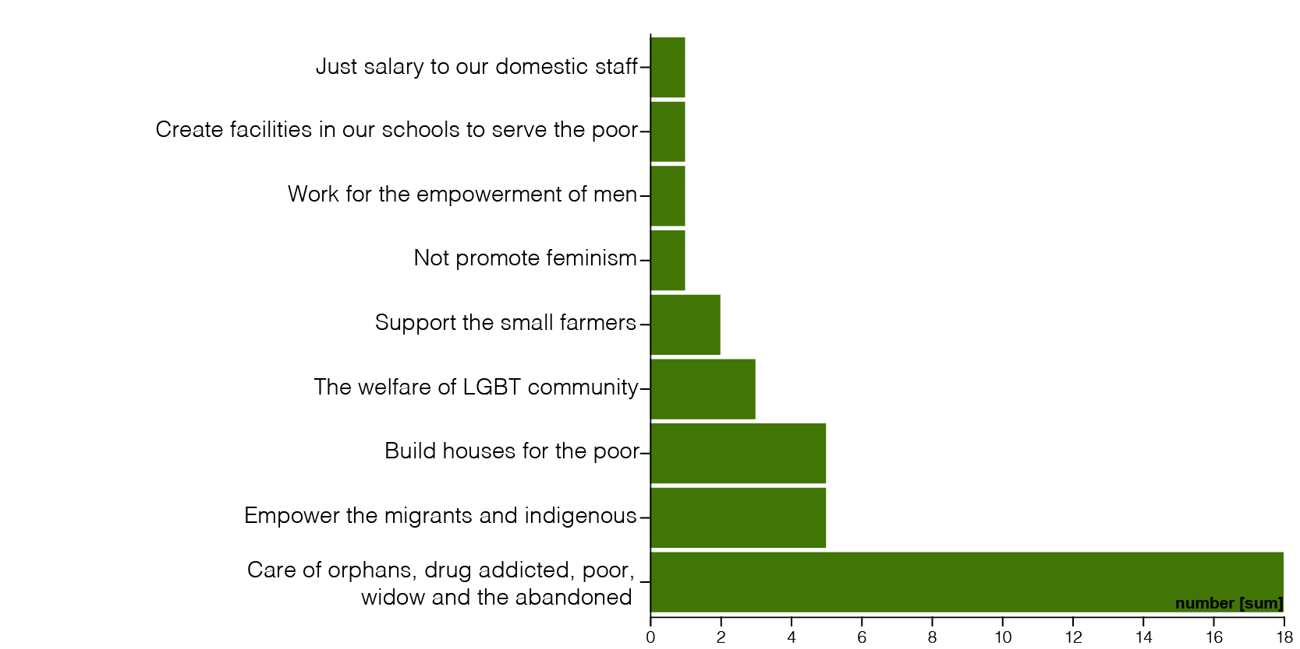

2 C) Interpretation of the data:

Presently the cry of the poor is answered by developmental projects among which education is predominant. Along with these, providing legal service to the poor is also taking place. Among the future actions, while continuing with the existing developmental projects there is new interests towards abolition of corruption which is a principal cause of poverty and to develop self-reliance of the poor through micro credit. There is an emerging awareness to work for the empowerment of women. A small number of respondents have also opted to work for the welfare of LGBT. Also there are minor opinions on the need to empower men and not to promote feminism while working for the empowerment of woman.

Laudato Si GOAL – 3. Ecological Economics:

It refers to the production and consumption of goods/food without destruction of the environment.

3 A) The Bible and Laudato Si on the Ecological Economics:

And the Lord God commanded the man, saying, you may surely eat of every tree of the garden, but of the tree of the knowledge of good and evil you shall not eat, for in the day that you eat of it you shall surely die (Genesis 2, 16-17)

The land must not be sold permanently, because the land is mine and you reside in my land as foreigners and strangers (Leviticus 25, 23)

Be sure you know the conditions of your flocks, give careful attention to your herds; for riches do not endure forever, and a crown is not secure for all generations (Proverbs 27, 34-35)

We have not yet managed to adopt a circular model of production capable of preserving resources for present and future generations, while limiting as much as possible the use of non-renewable resources, moderating their consumption, maximizing their efficient use, reusing and recycling them (LS 22)
Worldwide there is minimal access to clean and renewable energy (LS 26)
The principle of the maximization of profits, frequently isolated from other considerations, reflects a misunderstanding of the very concept of the economy (LS 195)

3 B) Commitments:

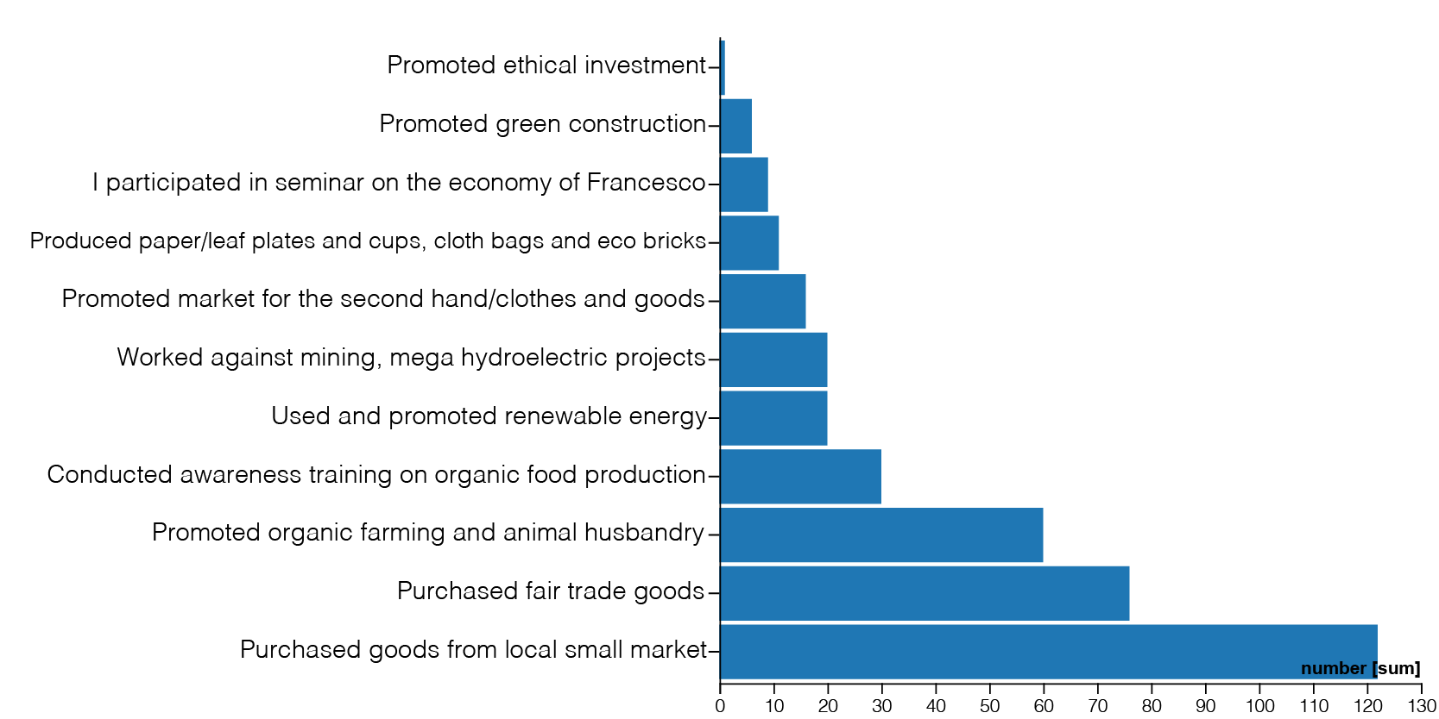
The activities we participated, during the last 3 years, to promote the Sustainable Production and Consumption:

The new commitments that we you want to make at least for the next 7 years:

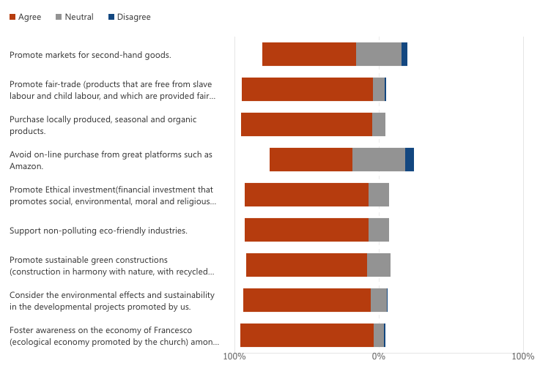

The additional commitments apart from the above:
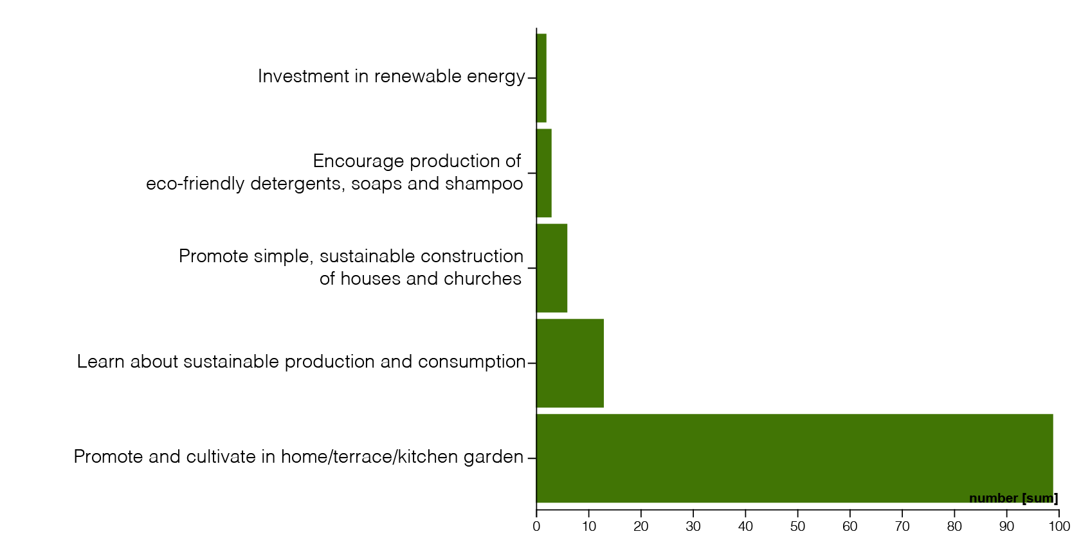

3 C) Interpretation of the data:

Buying goods in local markets and promoting fair trade are strong in present practice as well as in the future plans. On the other hand, there is equal percentage of members who are not ready to give up online shopping. The support for the non-polluting industries and eco-friendly products are encouraging. In the present practice, the promotion of green construction and ethical investment are low. This might be due to the fact that these works are carried out by the administration. But there is a strong desire to improve on these. Presently only a very few members know about the economy of Francesco but there is a very strong option to know and to foster it in the future. The lack of favor towards the use and sale of second-hand goods needs our attention.

Laudato Si Goal– 4. Sustainable Lifestyle:

It stands for personal life marked by less possession of goods, less carbon emission and absence of conspicuous consumerism.

4 A) The Bible and Laudato Si on leading Sustainable Lifestyle:

A pretentious, showy life is an empty life; a plain and simple life is a full life (Proverbs 13,7)

I have learned the secret of being content in any and every situation, whether well fed or hungry, whether living in plenty or in want (Philip 4,12)

Life does not consist in an abundance of possessions (Lk 12,15)

Since the market tends to promote extreme consumerism Ωto sell its products, people can easily get caught up in a whirlwind of needless buying and spending (LS 203)

If we can overcome individualism, we will truly be able to develop a different lifestyle and bring about significant changes in society (LS 208)
There is a nobility in the duty to care for creation through little daily actions…. such as avoiding the use of plastic and paper, reducing water consumption, separating refuse, cooking only what can reasonably be consumed, showing care for other living beings, using public transport or car-pooling, planting trees, turning off unnecessary lights (LS 211)

4 B) Commitments:

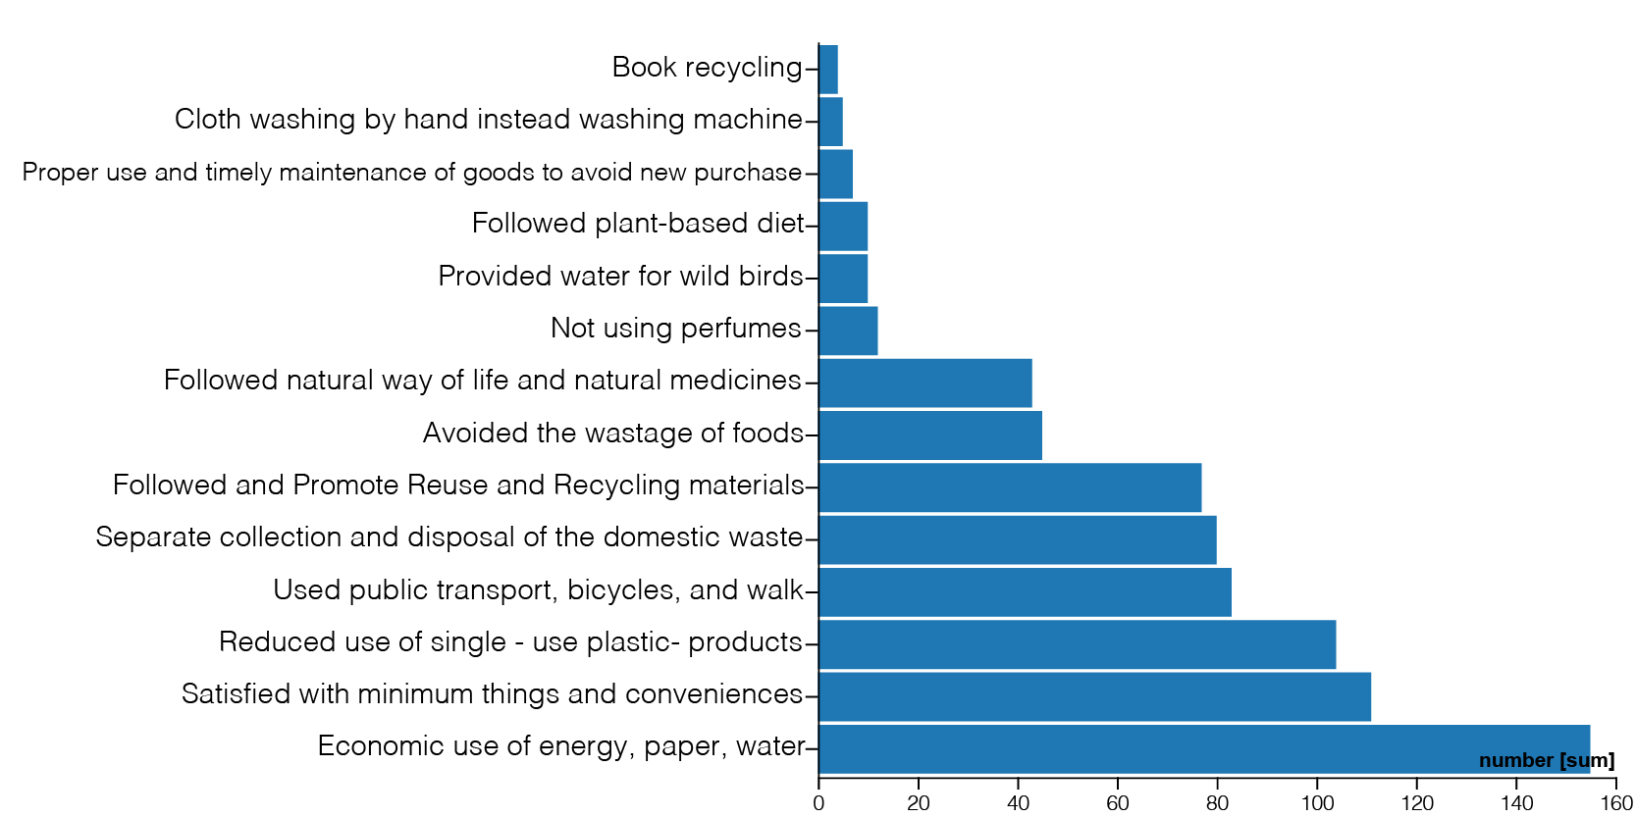
The activities we followed, during the last 3 years, to pursue Sustainable Lifestyle:

The new commitments that we you want to make at least for the next 7 years:

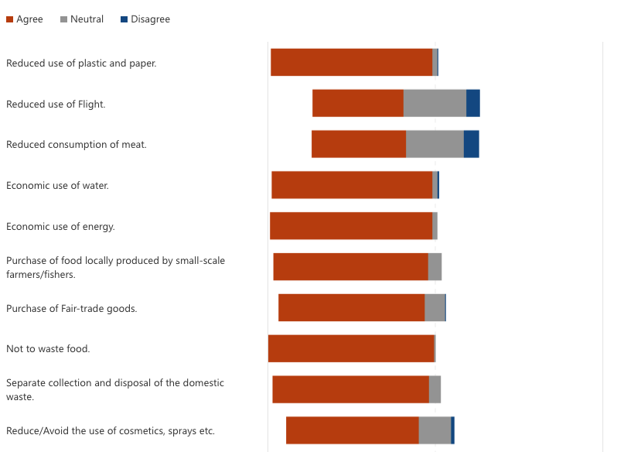

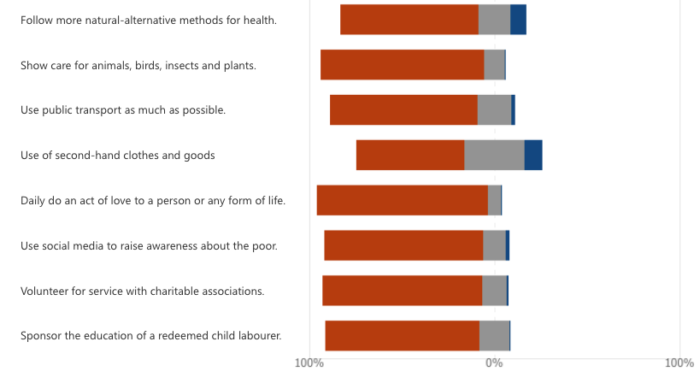

The additional commitments apart from the above:
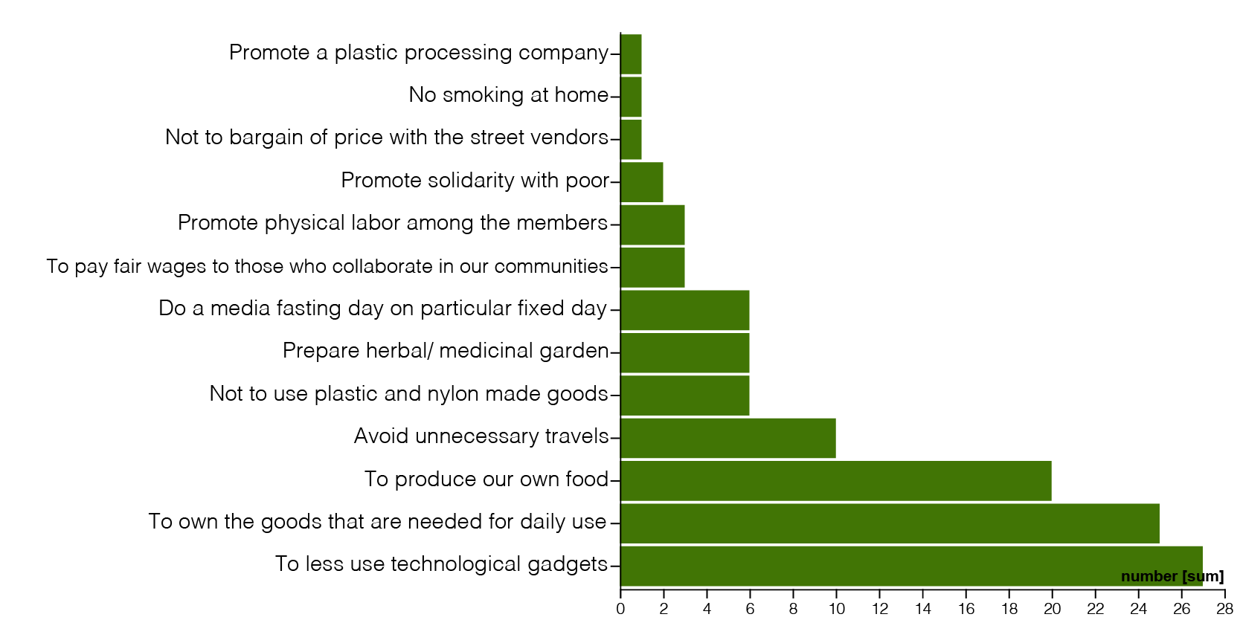

4 C) Interpretation of the data:

Presently there are strong practices on the economic use of water, energy, paper, single use of plastics, separate collection and disposal of domestic waste, recycling and reuse of goods. Also there is conscious practice of public means of transport. These are opted to be continued in the future too. Among the future actions not to waste food ranks number one. Purchase of fair trade goods and the goods from local market which were appreciated high in the ecological economy are opted to be for daily life by vast majority of respondents. Adopting plant based diet (reduced consumption of meat) ranks low among the options. There is emerging appreciation for the use of natural/herbal medicines. A few have opted to do media fasting, to avoid cosmetics and body spray, to do physical labour and to give just wage for the employees.

Laudato Si Goal– 5. Ecological Education:

It refers to the process of continuous learning on: how the nature functions; how all forms of lives are connected; the ecological changes that are happening and how the human beings can manage their behaviour to promote sustainability.

5 A) The Bible and Laudato Si on Ecological Education:

I will send you the seasonal rains. The land will then yield its crops, and the trees of the field will produce their fruit (Leviticus 26, 4)

The heavens proclaim the glory of God. The skies display his craftsmanship. They speak without a sound or word. Yet their message has gone throughout the earth, and their words to all the world (Psalm 19,1-4)

The axe is already at the root of the trees, and every tree that does not produce good fruit will be cut down and thrown into the fire (Mathew 3,10)

Environmental education has broadened its goals. Whereas in the beginning it was mainly centred on scientific information, consciousness-raising and the prevention of environmental risks, it tends now to include a critique of the “myths” of a modernity grounded in a utilitarian mindset-individualism, unlimited progress, competition, consumerism, the unregulated market (LS 210)

Ecological education can take place in a variety of settings: at school, in families, in the media, in catechesis and elsewhere. Good education plants seeds when we are young, and these continue to bear fruit throughout life. Here, though, I would stress the great importance of the family (LS 213)

It is my hope that our seminaries and houses of formation will provide an education in responsible simplicity of life, in grateful contemplation of God’s world, and in concern for the needs of the poor and the protection of the environment (LS 214)

5 B) Commitments:

The activities we followed, during the last 3 years, to grow in Ecological Education:

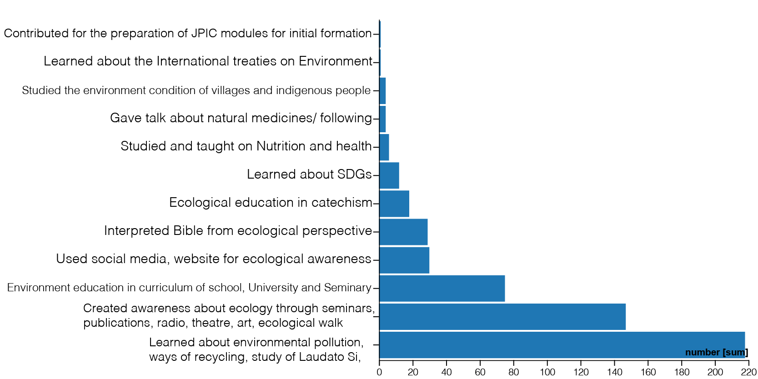

The new commitments that we you want to make at least for the next 7 years:

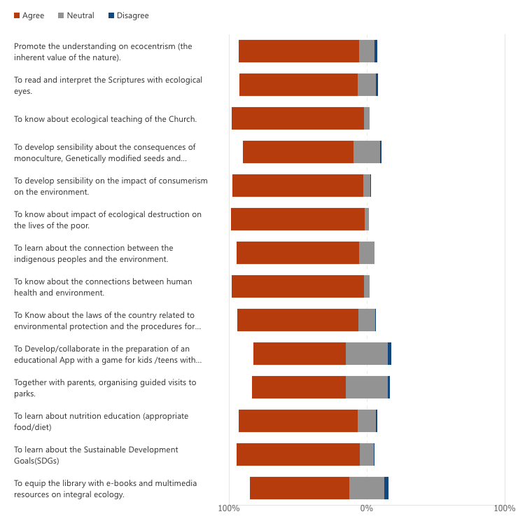

The additional commitments apart from the above:
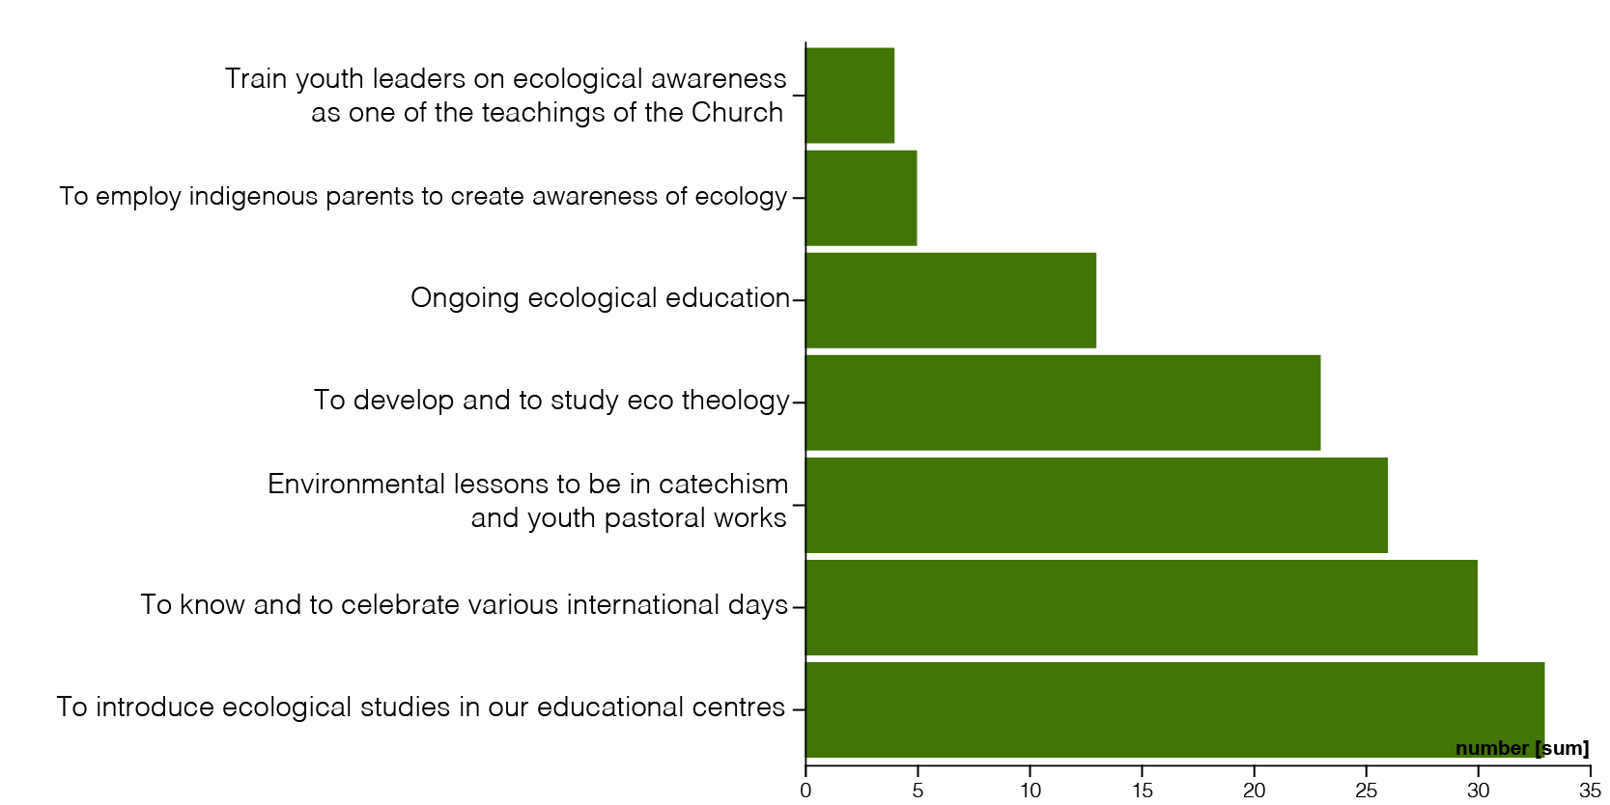

5 C) Interpretation of the data:

Presently the learning about environment and creating awareness on it is very strong. There is emerging inclusion of environmental studies in the curriculum of the schools, Universities, formation houses but there is a strong desire to improve this. There is sound knowledge about the impact of environment on the lives of the poor and the indigenous people. The reading of the Bible with ecological eyes, inclusion of ecology in catechism, study of the ecological teaching of the Church, eco theology, ecocentrism are emerging now and there is a growing aspiration to improve on these in the future. Among the future options the knowing about the relation of environment to health and nutrition is sufficiently expressed. There is only a small option to develop play app with environmental education and to collect e books. The level of knowledge about the environmental laws of the respective country and the international environmental treaties is not sound. The learning and the celebration of international days are not sufficiently reflected in this data.

Laudato Si Goal– 6. Ecological Spirituality:

It refers to the experience of the spiritual connection between human beings and the planet earth.

6 A) The Bible and Laudato Si on Ecological Spirituality:

The earth was formless and void, and darkness was over the surface of the deep, and the Spirit of God was moving over the surface of the waters (Genesis 1,2)

The Lord’s justice will dwell in the desert, his righteousness live in the fertile field (Is 32,16)

Where can I go from Your Spirit?, Or where can I flee from Your presence? (Ps 139,7)

Christians have not always appropriated and developed the spiritual treasures bestowed by God upon the Church, where the life of the spirit is not dissociated from the body or from nature or from worldly realities, but lived in and with them, in communion with all that surrounds us (LS 216)

The external deserts in the world are growing, because the internal deserts have become so vast. For this reason, the ecological crisis is also a summons to profound interior conversion (LS 217)

Each creature reflects something of God and has a message to convey to us…there is the recognition that God created the world, writing into it an order and a dynamism that human beings have no right to ignore (LS 221)

6 B) Commitments:

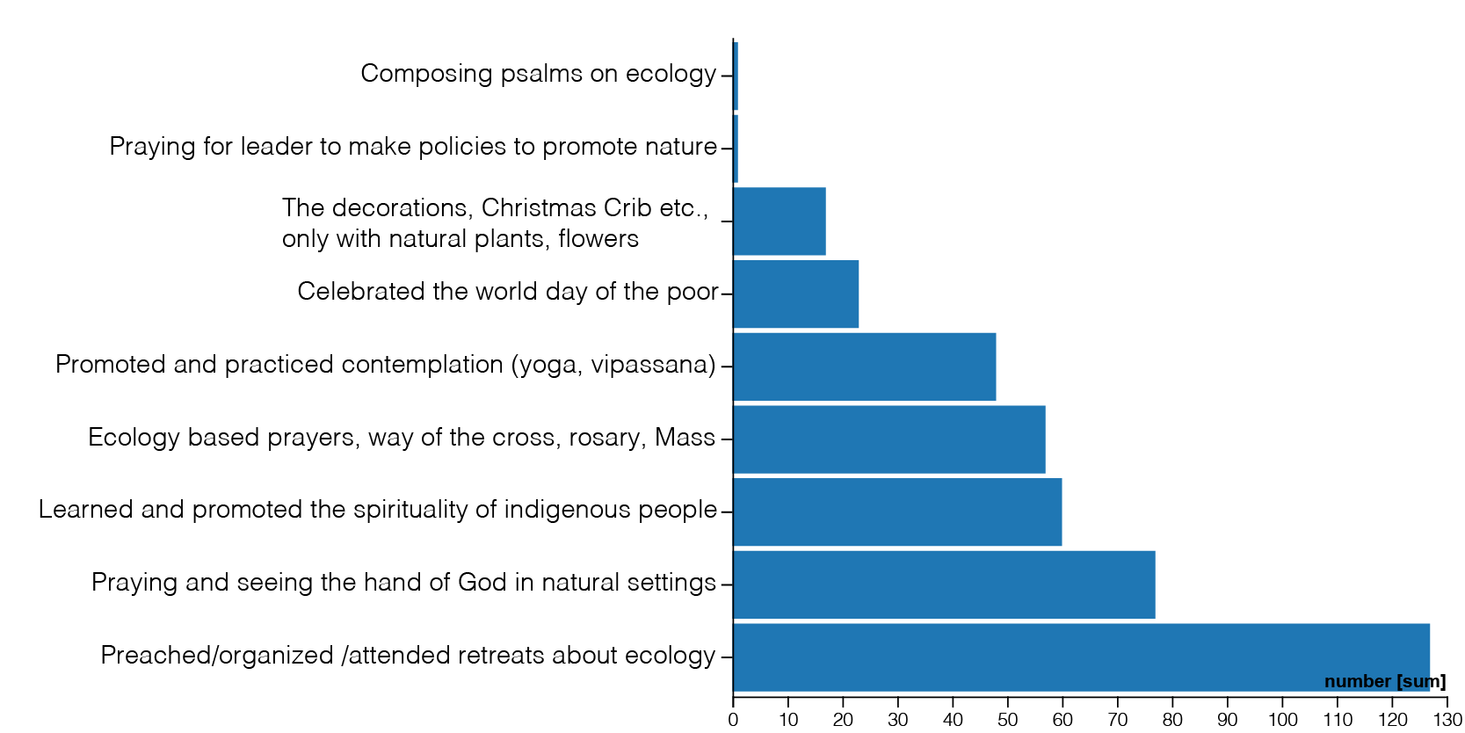
The activities we followed, during the last 3 years, to grow in ecological Spirituality:

The new commitments that we you want to make at least for the next 7 years:

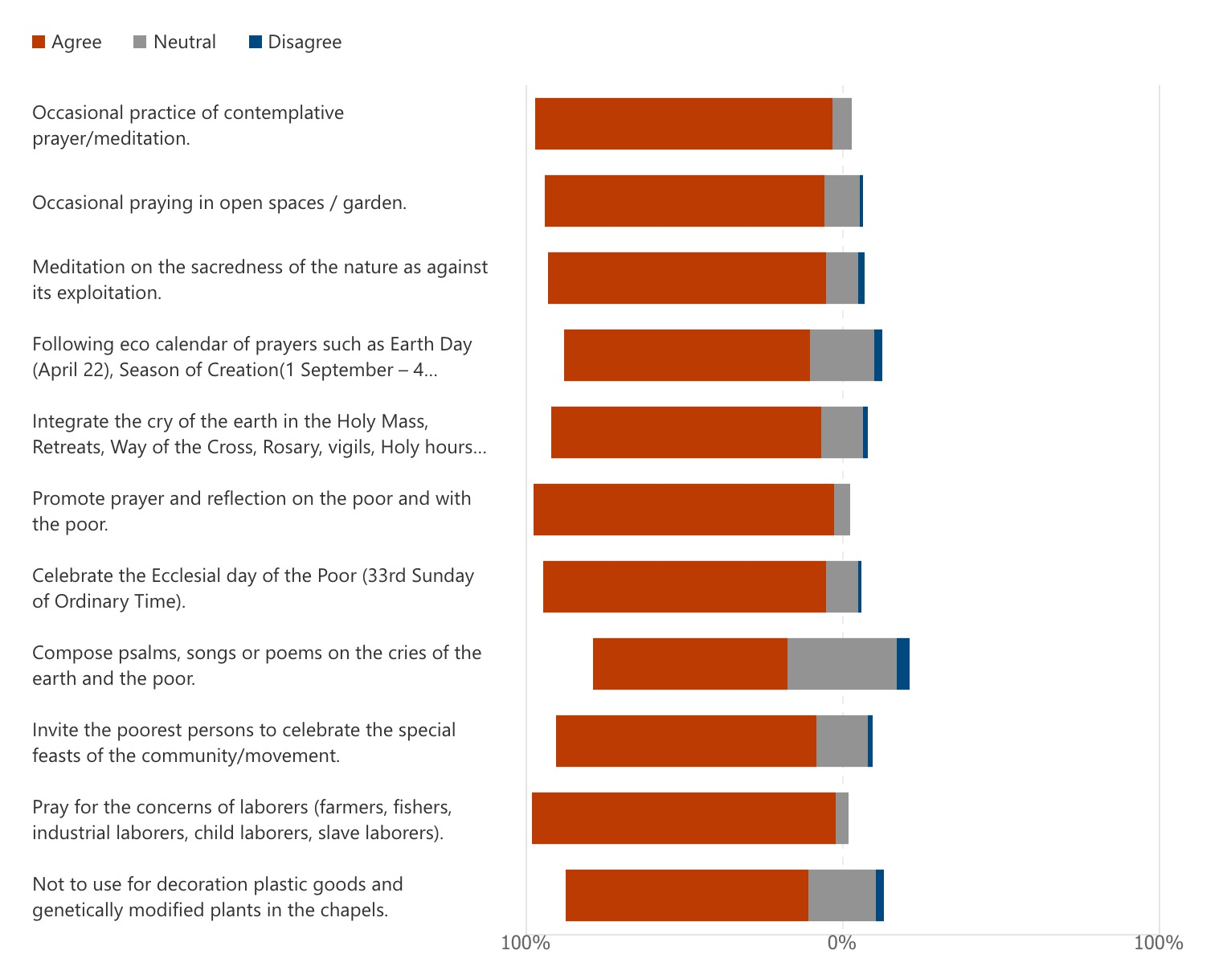

The additional commitments apart from the above:

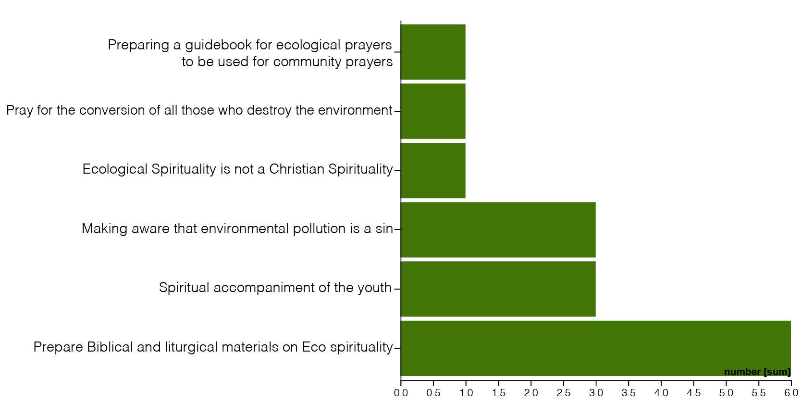

6 C) Interpretation of the data:

There is growing integration into prayers, liturgies and preaching the needs of the poor, the laborer and the environment. The need for preparing liturgical materials for eco spirituality is considerably expressed. There is increase in the learning and practice of contemplative prayer methods of Catholic, indigenous and eastern traditions (yoga, vipassana). There is growing consciousness to decorate the church without plastic, without cutting of trees and without genetically modified plants. The practice of praying, helped by appropriate resources made available by the CF on the International and Ecclesial days, is growing up. There is an awakening to consider the acts which cause environmental pollution as sin. On the other hand, in few geographical contexts the ecological spirituality is understood as non-Christian.

Laudato Si Goal– 7. Community involvement in Advocacy and Campaign
It refers to a set of actions planned along with others to promote integral ecology.

7 A) The Bible and Laudato Si on doing mission with others in network:

For where two or three are gathered in my name, there am I among them (Mt 18, 20)

If one member suffers, all suffer together; if one member is honoured, all rejoice together (1 Cor 12, 26)

I planted, Apollos watered, but God gave the growth (1 Cor 3, 6)

The climate is a common good, belonging to all and meant for all (LS 23)

A global consensus is essential for confronting the deeper problems, which cannot be resolved by unilateral actions on the part of individual countries (LS 164)

Environmental impact assessment should be… carried out in a way which is interdisciplinary, transparent and free of all economic or political pressure (LS 183)

7 B) Commitments:

The activities during the last 3 years, that we participated for doing Advocacy and Campaign for integral ecology in partnership with Ecclesial, Ecumenical, Inter Religious, Governmental and Non-Governmental Organizations:
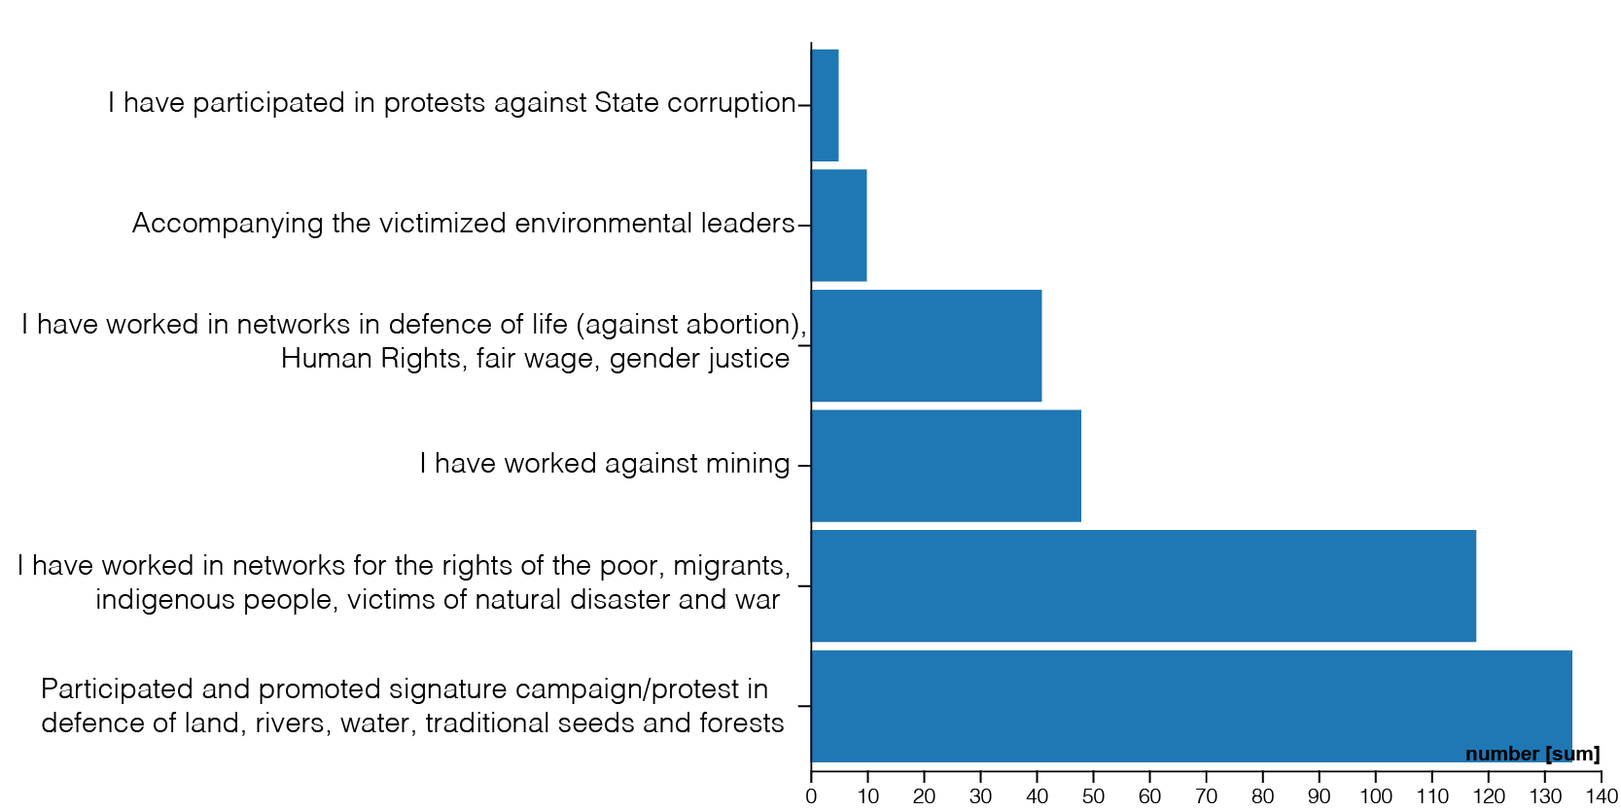

The new commitments that we you want to make at least for the next 7 years:

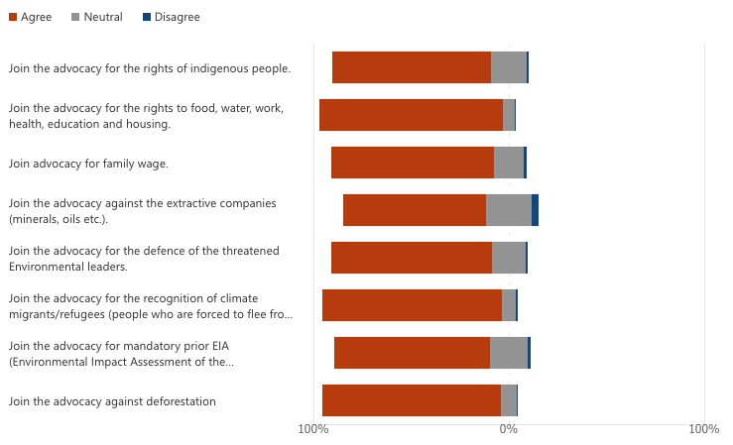

The additional commitments apart from the above:
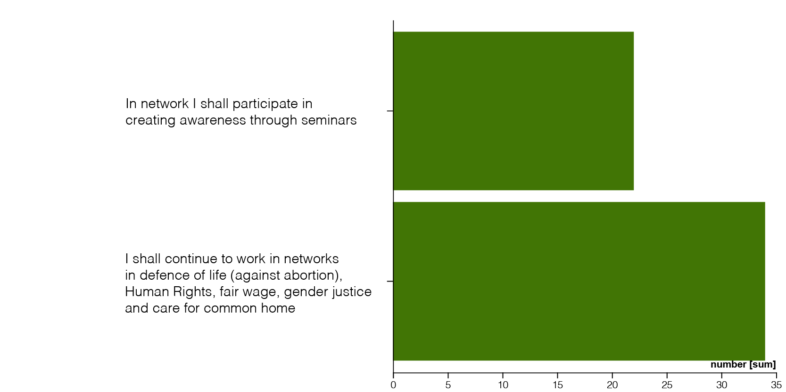

7 C) Interpretation of the data:

The respondents have strongly advocated and campaigned for the promotion of the environment rights and the rights of the poor, migrants, indigenous people and the victims of natural disasters and wars. Now there is growing desire to advocate for the rights of Climate Migrants, the realization of universal family wage and for the fundamental socio-economic and educational rights. Denouncing deforestation are seen in the present as well in the future agenda. In the past, the advocacy for the defense of life from womb to tomb, fair wage, gender justice has not received sufficient attention but now there is growing interest. Defending the rights of the environmental leaders has not been highly mentioned in the present practice as well in the future plans according to the data. The fight against corruption has strong backup in the LSG on the cry of the poor but only a very small number of respondents presently do this in network, and it is entirely absent in the future options which is an area of concern.

Conclusion:

The representatives of the branches of CF and Fr. Jose Enrique, CMF deserve our profound thanks for their roles in selection of samples and processing of data. We pray that these seeds be planted and bear fruit in our life and mission. Living in communion with all forms of life is no more an option but has become an obligation.

17.05.2021
(S. Vincent Anesthasiar CMF, For General SoMi Team, Missionari Claretiani
Curia Generalizia, Via Sacro Cuore di Maria, 5, 00197 Roma)

