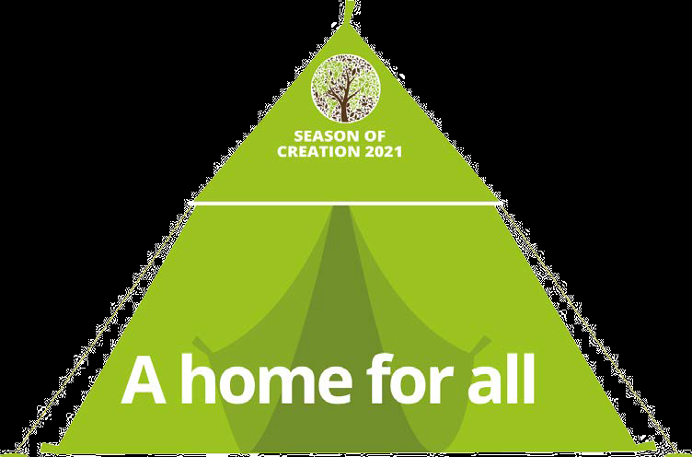
The Season of Creation
1 September 2021 – 4 October 2021
This year we will be uniting around the theme,
“A HOME FOR ALL? RENEWING THE OIKOS OF GOD.”

Oikos is the Greek word for “home,” or “household.”
By rooting our theme in the concept of oikos,
we celebrate the integral web of relationships
that sustain the well-being of the Earth.
This year’s symbol, Abraham’s tent,
signifies our commitment to safeguard a place for all
who share our common home, just as Abraham did in the Book of Genesis. The tent can also be present in liturgies or events throughout the Season of Creation as a symbol of the community’s intention to create a home for all.
(Each community will adapt the prayer proposal according to its own reality. The liturgical animator will familiarize herself with the content in advance).

History
The Season of Creation is a time to renew our relationship with our Creator and all creation through celebration, conversion, and commitment together. During the Season of Creation, we join our sisters and brothers in the ecumenical family in prayer and action for our common home.
Ecumenical Patriarch Dimitrios I proclaimed 1 September as a day of prayer for creation for the Orthodox in 1989. In fact, the Orthodox church year starts on that day with a commemoration of how God created the world.
The World Council of Churches was instrumental in making the special time a season, extending the celebration from 1 September until 4 October.
Following the leadership of Ecumenical Patriarch Dimitrios I and the WCC, Christians worldwide have embraced the season as part of their annual calendar. Pope Francis made the Roman Catholic Church’s warm welcoming of the season officially in 2015.
In recent years, statements from religious leaders around the world have also encouraged the faithful to take time to care for creation during the month-long celebration.
The season starts on 1 September, the Day of Prayer for Creation, and ends on 4 October, the Feast of St. Francis of Assisi, the patron saint of ecology upheld by many Christian denominations.
Throughout the month-long celebration, the world’s 2.2 billion Christians come together to care for our common home.

Prayer
Prepare the place of prayer with symbol of Abraham’s tent – our common home

Introduction: Lord God, today we give you thanks for all created things, especially for the earth, our mother and our home; for the plants and animals, our brothers and sisters; and for ourselves your last creatures. We give you thanks for water we drink which sustains our body. We are made of it. We give you thanks for the air we breathe in and out, which we need it every second. We give you thanks for the fire and sun the source of energy. Without them lives cannot continue. Oh, Lord, everything you have made is good.

Choose an appropriate song for the context
We prepare ourselves to continue praying with this psalm inspired the book of genesis, at the time of creation.

ANT : Everything you made, is good

In the beginning God created the heavens and the earth.  The earth was formless and empty,  darkness was over the surface of the deep,  and the Spirit of God was hovering over the waters. | Then God said, “Let the land produce vegetation: seed-bearing plants and trees  And God saw that it was good.  And there was evening, and there was morning—the third day.
God said, “Let there be light,” and there was light. And God said, “Let the water under the sky be gathered to one place, and let dry ground appear.” And it was so.  God called the dry ground “land,” and the gathered waters he called “seas.”  And God saw that it was good. | And God said, “Let there be lights in the vault of the sky to separate the day from the night,  the greater light to govern the day and the lesser light to govern the night.  He also made the stars.
God set them in the vault of the sky to give light on the earth, to govern the day and the night, and to separate light from darkness.  And God saw that it was good. And there was evening, and there was morning—the fourth day. | And God said, “Let the land produce living creatures according to their kinds:  the livestock, the creatures that move along the ground,  and the wild animals, each according to its kind.”  And it was so. And God saw that it was good.
And God said, “Let the water teem with living creatures, and let birds fly above the earth across the vault of the sky.” And God saw that it was good. | God created mankind in his own image,  in the image of God he created them;  male and female he created them. God saw all that he had made, and it was very good. And there was evening, and there was morning—the sixth day.

God blessed them and said,  “Be fruitful and increase in number and fill the water in the seas, and let the birds increase on the earth.” And there was evening, and there was morning—the fifth day. | ANT : Everything you made, is good

From the writings of Ven, Maria Anthonia Paris

“The more we went into that immense sea of waters the more my spirit plunged into the immense sea of God, when I looked at myself within the heart of my God and Lord more clearly than in a mirror.(…) The immensity of the sea reminded me of the immensity of God and those skies so wide brought to my mind the immense spaces of the glory of the saints.” (Maria Anthonia Paris, Autobiography 159)

We continue our prayer of praise and thanksgiving with the English song by clicking

SHOUT TO THE LORD (LYRICS) - YouTube
Scripture Reading (Gen 18,1-5)
The Lord appeared to Abraham near the great trees of Mamre while he was sitting at the entrance to his tent in the heat of the day. Abraham looked up and saw three men standing nearby. When he saw them, he hurried from the entrance of his tent to meet them and bowed low to the ground.
He said, “If I have found favor in your eyes, my lord, do not pass your servant by. Let a little water be brought, and then you may all wash your feet and rest under this tree. Let me get you something to eat, so you can be refreshed and then go on your way—now that you have come to your servant.”
From Enciclical Letter “Laudato si” 91-92m

A sense of deep communion with the rest of nature cannot be real if our hearts lack tenderness, compassion and concern for our fellow human beings. It is no coincidence that, in the canticle in which Saint Francis praises God for his creatures, he goes on to say: “Praised be you my Lord, through those who give pardon for your love”. Everything is connected. Concern for the environment thus needs to be joined to a sincere love for our fellow human beings and an unwavering commitment to resolving the problems of society.
Moreover, when our hearts are authentically open to universal communion, this sense of fraternity excludes nothing and no one. It follows that our indifference or cruelty towards fellow creatures of this world sooner or later affects the treatment we mete out to other human beings. We have only one heart, and the same wretchedness which leads us to mistreat an animal will not be long in showing itself in our relationships with other people. Every act of cruelty towards any creature is “contrary to human dignity”. We can hardly consider ourselves to be fully loving if we disregard any aspect of reality: “Peace, justice and the preservation of creation are three absolutely interconnected. Everything is related, and we human beings are united as brothers and sisters on a wonderful pilgrimage, woven together by the love God has for each of his creatures and which also unites us in fond affection with brother sun, sister moon, brother river and mother earth.

From the writings of St Anthony Mary Claret
At one in the afternoon we sailed. On reaching the boat, where people of all nationalities were gathered for that passage. (…) They also mentioned that there was another Spaniard on board, a Catalan, who was in very bad shape, having been robbed while crossing the harbor. Sure enough, it was the same man who was to have accompanied me and had not kept his word. When I saw him, he really was reduced to misery and I did what I could to console him.(…) When I had finished my prayers, an English gentleman walked over. I saw him coming toward me with some silver coins on a tray. When I saw him, I thought "What are you going to do? Will you accept the money or not?" I said to myself, "You don't need it, but those poor Spaniards do; so take it and give it to them." And that is just what I did. I accepted it, thanked the man, and went to divide it among those poor people, who went at once to the kitchen or refreshment counter to buy whatever food they needed. Other passengers did the same. They gave me money and I distributed it to the others, not keeping so much as a penny for myself although it had been intended for me. I didn't take a mouthful of the food they had bought;(129, 133-`34)

Action:

In a moment of silence think and write concrete action that your community will take to care for the earth and for our venerable brothers and sisters in our close neighborhood

Intercession:
Lord, everything that exist is you created with your infinite wisdom and care. Indeed, your works are all good. We pray for all people of good will to take necessary daily action to protect our common home and pass it to future generations – Lord make us care for our common home
- We pray for the leaders of countries that they may dialog and take decisions towards slowing down climate changes and devastation of world forests – Lord, make us care for our common home

- We pray for the persons behind the economic powers for the understanding that on them depends the future of this planet – Lord, make us care for our common home.

- We pray for all the vulnerable and the excluded, the hungry, the migrants who greatly are suffering from the effects of environmental damages, that they may be welcomed and helped – Lord, make us care for our common home.
Spontaneous petitions…

Final prayer:
Father we praise you for preparing the earth as a suitable home for all creatures, for your love and tender care, give us the wisdom and will, to work tirelessly to preserve it. Remove from our hearts the indifference and teach us your compassion to the poor and weak, help us to understand that this common home belongs to all your children and nobody is excluded. Amen.

