Prayer for Migrants and Refugees
TOWARDS AN EVER WIDER “WE”

The Church has been celebrating the World Day of Migrants and Refugees since 1914. It is always an occasion to express concern for different vulnerable people on the move, to pray for them as they face many challenges, and to increase awareness about the opportunities that migration offers. Every human being is a child of God, he or she bears the image of Christ, we ourselves need to see, and then to enable others to see, that migrants and refugees do not only represent a problem to be solved, but are brothers and sisters to be welcomed, respected and loved. They are an occasion that providence gives us to help to build a more just society, a more perfect democracy a more united country, a more fraternal world and a more open and evangelical Christian community.
Introduction:
As a Claretian Sister and Brother, we are called to pray and work together each in the midst of our own community, to make the Church become ever more inclusive; that she carries out the mission entrusted to the Apostles by Jesus Christ: “As you go, proclaim the good news that the kingdom of heaven has come near. Cure the sick, raise the dead, cleanse the lepers, cast out demons. You received without payment, give without payment."
Lord Jesus, today you call us to welcome the members of God’s family who come to our land to escape oppression, poverty, persecution, violence, and war. Like your disciples, we too are filled with fear and doubt and even suspicion. We build barriers in our hearts and in our minds. Help us to seek you in all that we do, so that we may be able to see in this human family a reflection of the divine unity of the one most Holy Trinity in whom we make our prayer. Amen
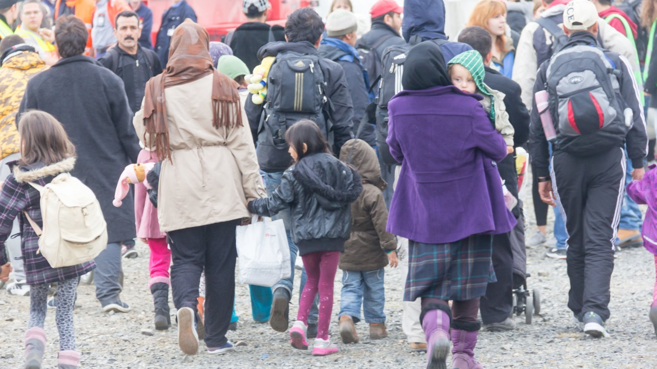

Opening Hymn:
Choose an appropriate song for the context
Before the reading it would be appropriate to watch some video about the travelling of refugees or migrants: https://youtu.be/nA8x4lYeYxs
A reading from the Letter of Fr. Claret
In San Sebastian we had already boarded the train for Madrid, but after sitting there for a long time, we had to return to our lodging because of a dispatch that the minister received from Madrid. On the following day we were ordered to head for France. That day l started meditating on the Flight of Jesus, Mary, and Joseph into Egypt and joined the Holy Family in Spirit. After a stay of five weeks in Pau, we moved on to Paris, where we have been for a month now. Just think of God's providence! Let us praise the mercies of the Most High! The Holy Family had to face privations, suffering, and labours, while this poor sinner has nothing but comforts and conveniences. The only thing that saddens me is the thought of the Holy Family in such suffering and myself in such delights. I can assure you that l have never in my life known so much help and care. This pains me and it is the only suffering l know. (EC II n. 1368)

Ant. Help us to grow in solidarity toward our brother and sisters in Christ who have journeyed far from their homes as migrants searching for food, peace and dignity.

Psalm: 143
Lord listen to my prayer  Turn your ear to my appeal  You are faithful, you are just; give answer.  Do not call your servant to judgment  For no one is just in your sight.  The enemy pursues my soul  He has crushed my life to the ground  He has made me dwell in darkness  Like the dead, long forgotten  Therefore my spirit fails  My heart is numb within me  I remember the days that are past  I ponder all your works  I muse on what your hand has wrought  And to you I stretch out my hands  Like a parched land my soul thirsts for you | Lord make haste and answer  For my spirit fails within me  Do not hide your face  Let me become like those in the grave  In the morning let me know your love  For I put my trust in you  Make me know the way I should walk  To you I lift up my soul  Rescue me, Lord from my enemies  I have fled to you for refuge  Teach me to do your will  For you, O lord, are my God  Let your good spirit guide me  In ways that are level and smooth  For your name’s sake, Lord save my life  In your justice save my soul from distress.

Reading: Leviticus 19: 33-34
When aliens settle with you in your land, you shall not oppress them. They shall be treated as native born among you, and you shall love them as people like yourselves, because you were aliens in Egypt. I am the Lord your God.
Reflection:
Try to imagine refugees as they journey into unknown and possibly dangerous territory. What might influence their decisions to risk a dangerous journey from home to strange country during pandemic time? What is the invitation or commitment the Lord address us with?

Prayer for refugees and Migrants:
Merciful God,
We pray to you for all men, women and children
Who have died after leaving their homelands in search of a better life during this pandemic time
Though many of their graves bear no name, to you each one is known, loved and cherished.
May we never forget them but honor their sacrifice with deeds more than words.

We entrust to you all those who have made a treacherous journey, enduring fear,
Uncertainty and humiliation, in order to reach a place of safety and hope.
Be close to these, your sons and daughters, through our tenderness and protection.
In caring for them, may we seek a world where no people are forced to leave their home
Their home and where all can live in freedom, dignity and peace.

Merciful God, Wake us from the slumber of indifference,
Open our eyes to their suffering and free us from the insensitivity born of worlds
Comfort and self-centeredness.
Inspire us as nations, communities, and individuals to see that those who come
To our shore are our brothers and sisters.

May we share with them the blessings we have received from your hand
And recognize that together as one human family,
We are all migrants, journeying in hope to you, our true home.
Where every tear will be wiped away
Where we will be at peace and safe in your embrace. Amen.

Intercession Prayer: Response: hear our prayer
- Loving Father we pray for all immigrant families suffering in the shadows from poverty and brokenness, May God bless them and protect them, for this we pray to the Lord.
- We pray for those who labour in the shadows of many countries for unjust wages and security, that we may bring dignity through reformation, for this we pray to the Lord
- We pray for all the migrant workers, that they may labour in safe and just conditions, and that we who benefit from their labour maybe truly grateful for what they provide for us, for this we pray to the Lord
- Let us pray for all the marginalized in our society, that they may deserve human dignity and respect, for this let us pray to the Lord
- Let us pray for all the immigrants, who face violence and hatreds in many countries, that they experience God’s welcome and love, for this we pray to the Lord
- We pray for those who are unemployed and undergoing hardships due to the coronavirus pandemic, may be strengthened by the spirit of Christ and may their loads be lightened by comforting word and actions of friends and family, for this we pray to the Lord.

Concluding prayer
Merciful and loving Father, We beseech you, open our hearts so that we may provide hospitality and refuge to migrants who are lonely, afraid, and far from their homes. Give us the courage to welcome every stranger as Christ in our midst, to invite them into our communities as a demonstration of Christ’s love for us. We pray that when we encounter the other, we see in her the face of your Son, when we meet a stranger, that we take his hand in welcome. Help us to live in solidarity with one another, to seek justice for those who are persecuted and comfort for those who are suffering. We ask this through our Lord Jesus Christ, your Son, who lives and reigns with you in the unity of the Holy Spirit, one God, for ever and ever. Amen.

