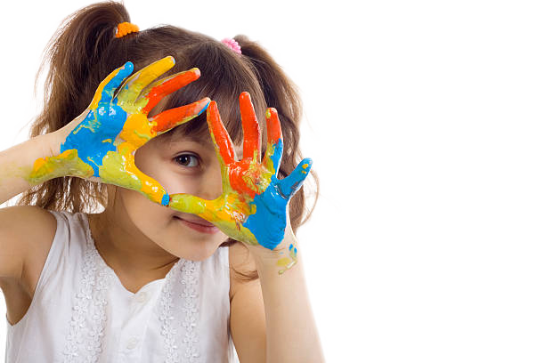
November 20
WORLD CHILDREN´S DAY
REIMAGINE
A BETTER FUTURE

1. Historical Review
https://www.unicef.org/world-childrens-day
1. On 20 November 1959 the UN General Assembly adopted the “Declaration of the Rights of the Child”. However, this declaration was not sufficient to protect children’s rights because it was not legally binding. After years of negotiations with governments around the world, religious leaders, NGOs and other institutions, the final text of the “Convention on the Rights of the Child” was agreed on 20 November 1989. It is binding on all countries that have signed it. This Convention on the Rights of the Child has 3 protocols that complement it:
- The protocol on the sale of children and child prostitution.
- The protocol on the participation of children in armed conflict.
- The protocol on a communications procedure for filing complaints with the Committee on the Rights of the Child.
2. The United Nations celebrates this International Children’s Day in honor of the approval of the Declaration of the Rights of the Child in 1959 and the Convention on the Rights of the Child in 1989, the most ratified international treaty in history. The UN General Assembly recommended in 1954 to set aside a day to foster brotherhood among the boys and girls of the world, and promote their well-being with social and cultural activities.
3. Universal Children’s Day aims to:
- Remind that children are the most vulnerable group and, therefore, they are the ones who suffer the most from crises and problems in the world.
- Remind that all children have the right to health, education and protection, regardless of the place of the world they were born.
- Make a global call (a conscience) on necessity of the smallest.
- Recognize the management and work of the people who work every day so that children have a better future.

2. Global Context
Current situation of children
- Migrant and displaced children.
In 2019, 33 million children were international migrants. Some are driven from their homes by conflict, poverty or climate change; others leave in the hope of finding a better life. Refugee children are 5 times more likely to be out of school than other children. Far too many encounter danger, detention, deprivation and discrimination on their journeys, at destination or upon return.
The suffering and exclusion of migrant and displaced children is not only unacceptable, but also preventable. A child is a child, no matter why she leaves home, where she comes from, where she is, or how she got there. Every child deserves protection, care and all the support and services she needs to thrive.
- Child Labour.
Economic hardship exacts a toll on millions of families worldwide – and in some places, it comes at the price of a child’s safety. Roughly 160 million children between the ages of 5 and 17 are engaged in child labour. Nearly half (79 million) are engaged in some of the worst forms of child labour, such as slavery, trafficking, forced labour or recruitment for armed conflict. These hazardous jobs have increased by 6.5 million since 2016. The data indicate a reversal of the 20-year trend of declining child labour. For the first time, there is an increase centred on children aged 5-11 years. With COVID-19 these figures may grow by a further 9 million.
- Extreme poverty
Across the world, about 1 billion children are multidimensionally poor, meaning they lack necessities as basic as nutrition or clean water. Of these, some 356 million experience extreme poverty, struggling to survive on less than $1.90 a day. Children – especially young children – are more likely to live in poverty than adults. They are also more vulnerable to its effects.
- Health vulnerability.
In 2019, 6.1 million children and young adolescents died, mostly from preventable causes. Children under the age of 5 accounted for 5.2 million of these deaths, nearly half of whom were newborn babies. Every six seconds, a child under the age of 5 dies somewhere in the world.
The spread of COVID-19 poses another threat to uprooted children. Even in the absence of a pandemic, migrant, refugee and internally displaced children routinely face numerous threats to their safety and well-being. But the crowded conditions in which many of them live - with limited access to safe water, sanitation and hygiene - make them particularly vulnerable to the immediate and secondary effects of infectious diseases such as COVID-19.
- Schooling.
258 million children will be out of school in 2030. 11 per cent of primary-school-aged children and 20 per cent of lower-secondary-aged children are not in school at all. Children and adolescents are excluded from education for many reasons. Poverty remains one of the most obstinate barriers, with children from the poorest households almost five times more likely to be out of primary school than those from the richest.

3. Time for Reflection
Message from Pope Francis
https://youtu.be/6umbsLWYcO0
- Every child who is marginalized, abused, abandoned, without schooling or without medical care is a cry that rises up to God.
- In each of them is Christ, who came to our world as a defenseless child; it is Christ who looks at us through the eyes of each of these children.
- Let us pray that every country decides to take necessary measures to make the future of children a priority, especially the future of children who are suffering today.

4. The Claretian Gaze
Claret and the promotion of children
Claret with his deep human sense generated responses to the needs of his time. Since he was a child he showed sensitivity and great docility to the Holy Spirit who filled and moved his apostolic mission. His creativity and ingenuity brought the grace of God in his evangelizing journey. An example of this is the promotion of farms in Cuba to take in children and young people to form their faith and skills as an alternative life, different from that offered on the streets, as he describes in his autobiography:
564. My plan in starting this ranch was to gather together poor boys and girls, many of whom were wandering the streets begging. At the ranch they were fed, clothed, and taught their religion, as well as reading, writing, and whatever art or trade they wanted to learn. One hour-and only one hour –a day they had to work on the ranch. This provided enough food to make the ranch self-supporting. Whatever else they might earn had to be put in a savings account. In this way, when they left the ranch they had had some formal education, learned a trade, and earned some money for their efforts.
565. The building itself was divided into two major sections, a boys’ wing and a girls’ wing, with a chapel between them. At church services the boys sat in the body of the chapel, while the girls had their own section in the upper galleries that connected with their wing, so that both sections were completely separated. The building had two stories; workshops and classrooms were on the first floor, dormitories on the second.
In our Claretian family, similar projects are also developed for the promotion and care of children at risk. An example is the experience of Hogares Claret (Claret Homes), a Claretian work that arose in Colombia and is also present in Mexico and Venezuela.
The mission of this non-profit institution is to accompany children, adolescents and adults affected by marginalisation, the consumption of psychoactive substances, violence or behavioural problems, and to help them find the meaning of their lives, in a perspective of re-establishing their rights and inclusion in the different spheres of society..
https://fundacionhogaresclaret.org

5. Prayer

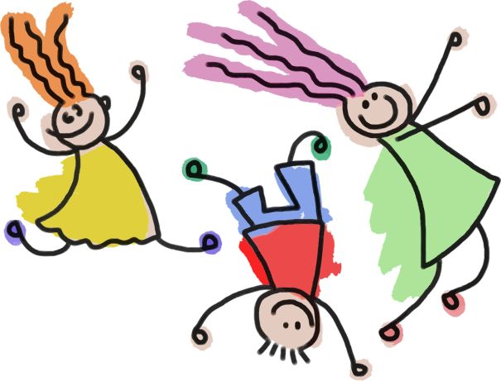
At the beginning...
Before we begin the prayer, we can watch this video together
https://www.youtube.com/watch?v=rApULMPWQIU

NOTE:
La vidéo est en langue espagnole. Dans Youtube,
vous pouvez activer les sous-titres dans d’autres langues. Pour ce faire, sélectionnez cette option dans le menu “Paramètres” ( ), et choisissez la langue souhaitée dans la section “Traduction automatique”.

Motivation
Boys and girls are the hope and represent the future of the nations in the world.
SONG: “De Lluvia y de Sol (Of Rain and Sun)” - Álvaro Fraile
https://youtu.be/O0T2lv5DzhY

The joys will come
surrounded by disasters.
New conquests
and some solitudes will come.
Each challenge will bring
its fears...
new abysses.
Good news will come.
You will see how something
gets in the way.
Some lights will come
casting new shadows
Each merit will bring vertigos...
new destinations.
and there we will be stronger
letting ourselves go
and there we will be stronger
letting ourselves get wet
we will have to keep
joy in tiredness
and patience in breakdown...
...WE ARE OF RAIN,
WE ARE OF SUN...

New smells will come
along with bad tastes
New songs, tides,
temptations will come
New reliefs will bring
the debris of a dream.
Tranquility will come
running some risks
we will assume keys
that open with a price
Each fruit will bring trouble...
new dangers.
And there we will be stronger
letting ourselves rain
and there we will be stronger
letting ourselves fall.
Know how to recognize
colours in puddles
and humor like a miracle...
…WE ARE OF RAIN
WE ARE OF SUN...
...WE ARE PAINTING THE SKY
IN A DIFFERENT COLOUR...

Invitation
We recite the psalm, feeling that we are the voice of the voiceless ... boys and girls who suffer from every condition, recognizing that God cares, giving protection to each one.
Psalm 24 (23): “The Lord is my Shepherd”

The Lord is my shepherd; I shall not want.
He makes me lie down in green pastures;
He leads me beside still waters.
He restores my soul;
He leads me in paths of righteousness
for His name’s sake.
Even though I walk through the valley of
the shadow of death, I will fear no evil;
for You are with me;
Your rod and Your staff, they comfort me.
You prepare a table before me
in the presence of my enemies;
You anoint my head with oil;
my cup runs over.
Surely goodness and mercy
shall follow me all the days
of my life,
and I will dwell in the house of
the Lord forever.
Gospel reading.
Let us allow ourselves to be touched by the words and gestures of Jesus (Mt 19: 13-15)
“Then little children were brought to Him that He might put His hands on them and pray. But the disciples rebuked them. But Jesus said:
—Let the little children come to Me, and do not forbid them. For to such belongs the kingdom of heaven.
He laid His hands on them and departed from there.”
WORD OF THE LORD

Meditation.
Scripture tells us that man and woman are created by God in his own image. Could any more forceful statement be made about our human dignity? The Gospel speaks to us of the affection with which Jesus welcomes children; he takes them in his arms and blesses them (cf. Mk 10:16), because “it is to such as these that the kingdom of heaven belongs” (Mt 19:14). Jesus’ harshest words are reserved for those who give scandal to the little ones: “It were better for them to have a great millstone fastened around their neck and to be drowned in the depth of the sea” (Mt 18:6). It follows that we must work to protect the dignity of minors, gently yet firmly, opposing with all our might the throwaway culture nowadays that is everywhere apparent, to the detriment especially of the weak and the most vulnerable, such as minors.
(...) Sentirse mirado por los ojos de los niños es una experiencia que todos conocemos y que nos toca en lo más hondo del corazón, y que también nos obliga a un examen de conciencia. ¿Qué hacemos para que estos niños nos puedan mirar sonriendo y conserven una mirada limpia, llena de confianza y de esperanza? ¿Qué hacemos para que no se les robe esta luz, para que esos ojos no sean perturbados y corrompidos por lo que encontrarán en la red, que será parte integral e importantísima de su ambiente de vida?
POPE FRANCIS. From the adress to the participants in the Congress
on “Child dignity in the digital world” (6 october 2017)

Final prayer

For the children who leave their fingers
full of chocolate on everything they touch,
who jump in puddles
and ruin their new trousers,
who eat sweets before lunch
and who never find
their shoes in the morning...
For the children who stare at the photographers
from behind barbed wire,
who have never walked down the street
with a new pair of shoes,
who have never played “enchanted”
and who were born in places
where we would never go near,
which is where they will probably die...
For the children who give us kisses
candy-sticky kisses and bouquets of flowers,
who hug us tightly,
who watch with amazed eyes
their father as he shaves
and their mother as she puts on her make-up,
who make noise when they eat their soup...
For the children who have never eaten dessert,
who have no favourite blanket to carry
everywhere, who watch their parents suffer,
who approach our cars at every crossroads begging with their eyes,
who don’t have toilets to wash themselves,
and whose photos appear in police stations
and not in their parents’ offices...
For the children whose nightmares
happen in broad daylight,
who eat whatever they can find,
who sleep under the sky
sheltered by newspapers,
who go to sleep hungry and wake up hungry, who have no direction...
For the children who like to be carried
and for those who have to be carried,
for those who give up
and for those who keep on fighting,
for those who can’t find hands to hold...
For all these children, Lord, I want to pray today, because they are all precious,
they give a new form of love to our lives and a reason to live, because they make us feel the need to commit ourselves
to build a more just world...
I pray for our children, those who were born
and those who will be born,
because they are the best hope for our world, the compensation for our work,
the fulfilment of our incomplete dreams,
the guarantee of our immortality...
and the proof that God
has not lost hope in mankind...
For all the children of the world
that GOD may bless them
with love and joy. AMEN

6. Commitment
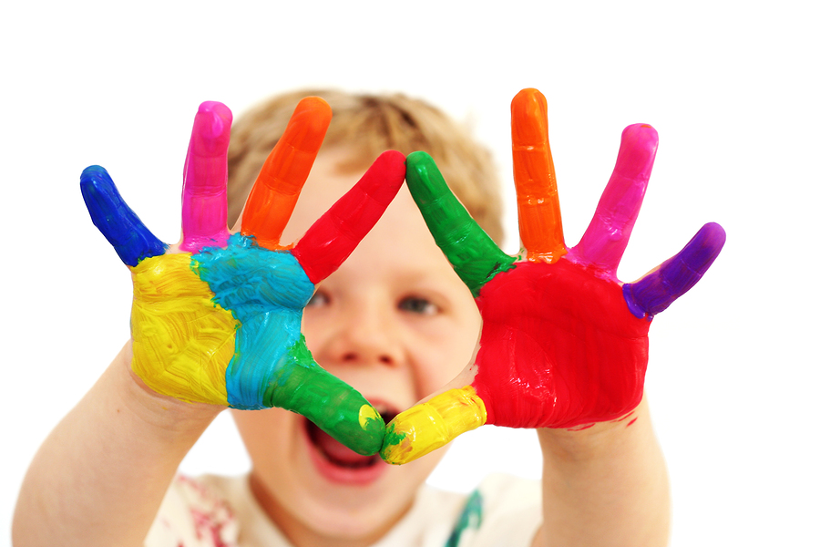
What can we do personally?. With our brothers and sisters, the poorest, the most defenceless and vulnerable in their rights; learn to stand up for them as God looks upon his children with love, tenderness and compassion.
What can we do as a community?. Specify our commitment in favor of children in each of the mission posts where we live.
What can we do as a Claretian family?. Get to know the institutions of our Claretian family that work in the promotion and care of children. To pray and support these missionary positions.

