World Food Day
16 October
"Better production, better nutrition, a better environment and a better life."

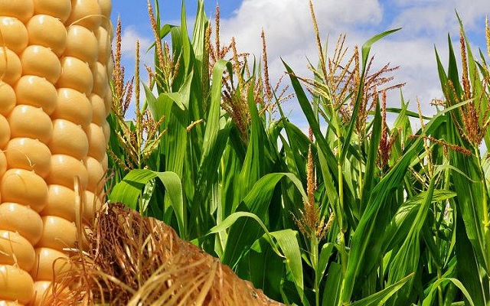
Nutrition
Production
Better environment

"For I was hungry and you gave me no food; I was thirsty and you gave me no drink."
Mt 25; 42

"Better production, better nutrition, a better environment and a better life."
INTRODUCTION
We gather Lord to give thanks for the gift of food that as we pray we receive from the earth and from the work of men and women. We are brothers and sisters of each of the people who go hungry and thirsty; in the world 17% of food production is wasted while many do not get balanced diet. Open our hearts Lord, forgive us our inaction, complicity and inadequate responses to this cry.
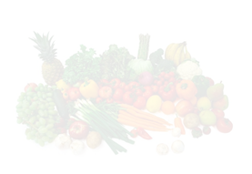
FOOD DAY
On every October 16th, since 1979, the World Food day is commemorated. World Food Day is promoted by the Food and Agriculture Organization of the United Nations (FAO), with the clear objective of reducing hunger in the world. This year's slogan is Our Actions are Our Future. Watch 1-minute video:
https://youtu.be/635fS0kw1RY

FOOD DAY
Food is the essence of life and the cornerstone of our cultures and communities. Preserving access to safe and nutritious food is an essential part of the response to the coronavirus disease (COVID-19), especially for the world's poorest and most vulnerable, who have been hardest hit by the pandemic and who will be most affected by the resulting economic shocks.

World Food Day calls us to carry out responsible agricultural activities that preserve natural resources such as soil, rivers, streams, lakes and seas for the care of our environment and climate. It is important to reflect on the actions carried out in the macro extensions of food production which mostly degrade or destroy natural habitats and contribute to the extinction of species. Pope Francis in the encyclical Laudato Sí ' invites us to take care of our common home. We must avoid the inequalities and injustices that permeate the current agri-food systems of today's society.
BIBLE READING

PSALM 67

May God be gracious to us and bless us
and make his face shine on us
so that your ways may be known on earth,
your salvation among all nations.

May the peoples praise you, God;
may all the peoples praise you.
May the nations be glad and sing for joy,
for you rule the peoples with equity
and guide the nations of the earth.
May the peoples praise you, God;
may all the peoples praise you.

The land yields its harvest;
God, our God, blesses us.
May God bless us still,
so that all the ends of the earth will fear him.
Introduction to Gospel:
The Gospel speaks of those who are hungry and thirsty, and how Christians care for them, as if they were Jesus himself.

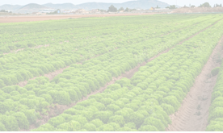

Mt 25:34-40
Then the King will say to those on his right hand, 'Come, you blessed of my Father, inherit the kingdom prepared for you from the foundation of the world. For I was hungry and you gave me food, I was thirsty and you gave me drink, I was a stranger and you welcomed me, naked and you clothed me, sick and you visited me, in prison and you came to me. Then shall the righteous answer him, saying, Lord, when saw we thee an hungered, and fed thee? or thirsty, and gave thee drink? and when saw we thee a stranger, and took thee in, or naked, and clothed thee? or when saw we thee sick, or in prison, and came unto thee? And the King shall answer and say unto them, Verily I say unto you, Inasmuch as ye have done it unto one of the least of these my brethren, ye have done it unto me.
MOMENTS OF REFLECTION

Be thankful for the food received today. Thank God for the one who sowed it, planted it, watered it, milked it, fed the chicken, the one who preserved the water. Bless the one who transported it, the one who bought and cooked it, the people with whom you shared it. If you have been fortunate enough to actively participate with your hands in this process you can feel in communion with so many other people in our world who care for, cultivate, nurture and preserve it.
Bring to your heart and memory the face and name of a person or family who does not have the nourishment necessary for life. Bless their daily search and struggle to get what is rightfully theirs.
"Today, believers and non-believers alike agree that the earth is essentially a common inheritance, the fruits of which should benefit all. For believers, this becomes a matter of fidelity to the Creator, because God created the world for all." Laudato Si, no. 93.

REFERENCE TO CLARET

Aut: 131. In this position, I meditated on how Jesus might have rested when he set out in the boat with his disciples. It turned out to be an ideal meditation, for the Lord even chose to add something of a tempest to it. I was just about to doze off when such a storm arose that we were shipping water. I sat motionless on my pile of rope and pulled my cloak over my head. I had a little bundle of provisions and my hat in my lap, and I pressed them close to my body, leaning my head forward a bit so that the water from the waves that were crashing over the boat could run off. When I heard a wave striking I would bow my head, brace my
back to it, and the water would come rushing over me.

Aut.132. Thus I passed the whole night until the dawn came and with it a rain that stilled the tempest. First I had been drenched with seawater and now I was being drenched with sweet rain-water. My entire luggage consisted of a shirt, a pair of socks, a handkerchief, a folding razor, a comb, my breviary, and a very small edition of the Bible. Since deck passengers were given nothing to eat, they had to carry their own
provisions for the trip. Knowing this before I left Marseilles, I had bought my provisions, which consisted of a pound-loaf of bread and a piece of cheese. These were all my provisions for the five days from Marseilles to Civitavecchia-stops, storms, and all.23 The storm had been so strong that a great deal of water had washed over me. My cloak was drenched, and the bread and cheese were
soggy, but I had to eat them as they were. Although they were quite salty I was so hungry that they tasted very good to me.

MESSAGE OF POPE FRANCISCO
on the occasion of the pre-Summit on ''Food System Summit 2021'' 26.07.2021
This pandemic has confronted us with the systemic injustices that undermine our unity as a human family. Our poorest brothers and sisters, and the Earth, our Common Home that “cries out to us because of the harm we have inflicted on her by our irresponsible use and abuse of the goods with which God has endowed her”, demand radical change.

We develop new technologies with which we are able to increase the planet's capacity to bear fruit, yet we continue to exploit nature to the point of barrenness, thus expanding not only the deserts of the earth, but also internal spiritual deserts. We produce enough food for all people, but many go without their daily bread. This “constitutes a genuine scandal” , an offence that violates basic human rights. Therefore, it is everyone’s duty to eliminate this injustice through concrete actions and good practices, and through bold local and international policies.

From this perspective, the careful and correct transformation of food systems plays an important role, which must be geared towards being able to increase resilience, strengthen local economies, improve nutrition, reduce food waste, provide healthy diets accessible to all, and be environmentally sustainable and respectful of local cultures.

If we are to guarantee the fundamental right to an adequate standard of living and meet our commitments to achieve Zero Hunger, it is not enough to produce food. We need a new mindset and a new holistic approach and must plan food systems that protect the Earth and keep the dignity of the human person at the centre; that ensure enough food globally and promote decent work locally; and that feed the world today, without compromising the future.

It is essential to restore the centrality of the rural sector, on which the fulfilment of many basic human needs depends, and it is urgent that the agricultural sector regain a priority role in the political and economic decision-making process, aimed at outlining the framework of the post-pandemic “re-start” process that is being constructed. In this process, small farmers and farming families must be considered as key actors. Their traditional knowledge should not be overlooked or ignored, while their direct participation allows them to better understand their priorities and real needs.

It is important to facilitate the access of small farmers and family farming to the services necessary for the production, marketing and use of agricultural resources. The family is an essential component of food systems, because it is in the family that “we learn how to enjoy the fruits of the earth without abusing it. We also discover the most effective means for spreading lifestyles respectful of our personal and collective good”. This recognition must be accompanied by policies and initiatives that fully meet the needs of rural women, promote youth employment and improve the work of farmers in the poorest and most remote areas.

(https://press.vatican.va/content/salastampa/it/bollettino/pubblico/2021/07/26/0480/01032.html)

PRAYER OF PETITION

Father, with Pope Francis, we pray for our "Common Home", that it may be a place where every human being can live in dignity, making use of the resources that God has offered to us all. May the logic of exploitation cease and give way to a civilization of love in which the rich care for the poor by putting themselves at their service. Let us pray to the Lord

We present to you Father the peasants who work to bring food to our tables so that their hard work will be recognized, respected and they will have the means to have a dignified life. Let us pray to the Lord

For each one of the persons and associations who, in the soup kitchens, food banks, parish offices, generate gestures of food solidarity and those who struggle for food justice, for landless peasants and indigenous people, for those who denounce situations of abuse and injustice. Let us pray to the Lord

. For each one of the people who make it possible for the food we need to live to reach our table every day: farmers, transporters, vendors, bakers, cooks. Let us pray to the Lord

For the people who suffer hunger because of wars, climate change and injustice. We especially present to you the pain of mothers who have nothing to feed and see their children grow. Let us pray to the Lord

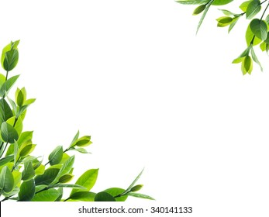

ACTION LINES

In addition to knowing and appreciating, we can simply and humbly join in the actions proposed by FAO for individuals and families all over the world
- Choosing diverse nutritious foods instead of highly processed ones, which increases the demand for healthy foods.
- In 2021 we commemorate the International Year of Fruits and Vegetables, which reminds us to eat more fresh produce and learn about local varieties.
- Add plant-based proteins such as nuts and legumes to our diet, which are cheaper than animal proteins and more respectful of our planet.
- Plan and organize our shopping and food preparation to avoid food spoilage and waste.
- Seek labels endorsed by FAO and others that attest to sustainable production conditions for producers and the planet.
- Be an advocate for healthy, sustainable diets! Share your opinion with your community and make sure healthy foods are available in schools, care centers, and other public places.

Closing prayer:

God our Father and Mother, may the cries of the hungry people reach the ears of the leaders. Inspire them to reduce weapons and increase food. May all your creatures live without hunger. Amen

